\

Chapter 1: Introduction
The impact of Alzheimer’s Dementia (AD) and other subtypes of dementias on unpaid caregivers for people with dementia is difficult to measure but indeed very significant. The responsibilities of dementia caregiving are complex and vary greatly (Carmeli, 2014). In addition, the number and relationship of unpaid caregivers to the individual with dementia is variable. Typically, caregiving roles are carried out by spouses, children, and siblings, but more distant relatives, neighbors, or friends may also provide unpaid caregiving assistance (Carmeli, 2014). Dementia caregiving responsibilities can be a long-term commitment for caregivers of people with dementia. The average life expectancy for a person following a dementia diagnosis is between four and ten years. This data further underscores the importance of caregiving and the heavy burden dementia caregivers face (Xie et al., 2008). Older adults who meet diagnostic criteria for a dementia diagnosis often require dependent care from family caregivers or community-based healthcare facilities (Albert & Freeman, 2010). A large proportion of caregivers report caring for someone with an AD diagnosis (Gaugler, James, Johns, Scholtz & Weuve, 2016). Many unpaid caregivers have no choice but to provide caregiving assistance due to financial reasons (Gaugler et al., 2016). The Alzheimer’s Association estimates that dementia-specific health care costs in the U.S. will leap from $236 billion in 2016 to more than $1 trillion by 2050 (He, Goodkind & Kowal, 2016). The impact of caregiving for persons with dementia involves a wide range of systems, including the person with dementia, the caregiver, and a wide range of other stakeholders. Clearly, the burden of caregiving for persons with dementia is a significant societal issue that requires further investigation.
Many physicians and health care professionals may not have adequate time, training, or resources to address coordinating all aspects of quality dementia care without specialized cognitive medical support resources (Belmin et al., 2012; Chodosh et al., 2007; Wenger et al., 2003). Cognitive medical support typically refers to physicians and allied health professionals with specialized training in areas such as behavioral neurology, nursing, occupational and physical therapy, and social work. A coordinated multidisciplinary approach to the care of people with dementia and their caregivers remains an underdeveloped opportunity within the field of gerontology (Alzheimer’s, 2018; Grand, 2011). Multidisciplinary cognitive support care approaches can help address the “complex range of cognitive, physical, social, and emotional problems associated with dementia” (Grand, 2011, p. 126) and are increasingly integrating “a broader focus extending to family members, caregivers, and support networks” (Grand, 2011, p. 133; Zuchella et al., 2018). Multidisciplinary cognitive support care approaches provide opportunities for caregivers to provide corroboration of the symptoms and experiences of the person with dementia and potentially reduce caregiver distress and connect caregivers to important additional social service and other community resources beyond the typical healthcare setting alone (Grand, 2011). The impact of multidisciplinary cognitive clinics on the experience of quality of life among caregivers for people with dementia remains an essential area for continued scientific inquiry (Zuchella, et al., 2018). This study will endeavor to elucidate additional valuable information that can contribute to our collective understanding of quality of life for caregivers of people with dementia.
In 2014, the number of adults aged >65 years old with Alzheimer’s Disease or related dementias (ADRD) was estimated at 5.0 million or 1.6% of the total U.S. population. It is predicted that the burden of ADRD will reach a staggering 13.9 million adults, or 3.3% of the population, by 2060 (Matthews et al., 2018). Of those diagnosed with ADRD, disparities in prevalence include a 3.6% greater occurrence in women over men; more than a third of ADRD diagnoses are found in older adults over the age of 85 years of age, of which 43% identify as Black and 40% identify as Hispanic (40%) (Matthews, et al., 2019).
In addition to the societal costs associated with the dementia care recipient, caregivers for people with dementia experience many significant challenges. Once the diagnosis of AD is made, individuals may become caregivers precipitously without the necessary skills or training needed for the caregiving role (Carmeli, 2014). Tangible negative impacts of caregiving can include missed work time, cutting back working hours or ceasing work entirely, and losing benefits (Alzheimer’s, 2018). Among caregivers for people with dementia, nearly 30% reportedly deferred their own care needs in support of caring for a loved one with dementia and are disproportionately likely to report a fair to poor health status, thus increasing the potential for decreased quality of life (QOL) (Alzheimer’s, 2018). Caregiving responsibilities may also negatively impact caregivers’ abilities to engage in social activities, ordinary family and household tasks, and self-care and expose caregivers to potential injury (Carmeli, 2014). Negative psychological impacts may include depression, anxiety, and nervousness (Carmeli, 2014; van der Lee, et al., 2014), further compounding the social problems surrounding QOL for unpaid caregivers for people with dementia. Caregivers for people with dementia also experience significant determinant factors, including challenges to general self-functioning, variability in receiving the necessary level of support from others, health quality, psychological problems, perceived deficits in competence and level of self-efficacy, and coping traits (van der Lee, et al., 2014). These factors make caregivers for people with dementia more at-risk to experience challenges to quality of life. In addition to the personal and societal health challenges the dementia care recipient experiences, other immense personal and societal health challenges result from decreased caregiver quality of life experience. These threats to caregiver quality of life demonstrate a clear need to further address dementia caregivers’ quality of life experiences and the potential positive impact that cognitive support clinics may offer this vulnerable population.
The following chapter will provide an overview of the planned research study designed to evaluate the impact of a cognitive support clinic on dementia caregiver QOL. This content will include the background of the study, research literature gaps; problem statement and significance; theoretical foundations; researcher’s positionality; purpose, research questions and hypothesis, the rationale for the methodology, definition of terms, limitations, and summary and organization of the remainder of the study.
Background of the Study
Over the past decade, the U.S. population over the age of 65 and older has grown by more than a third, thus propelling the aging demographic into being the most rapidly growing segment of U.S. society (U.S. Census Bureau, 2020). According to the U.S. Census Bureau’s Population Estimates Office, since the Baby Boomer population began to reach age 65, “there’s been a rapid increase in the size of the 65-and-older population” and goes on to further reveal “no other age group saw such a fast increase” (U.S. Census Bureau, 2020). By 2060, this older adult group is predicted to increase to 23.6% of the population, with 4.7% estimated to be over the age of 85 years (Federal Interagency Forum on Aging-Related Statistics, 2016). With advanced age comes an increased risk for additional individual and public health challenges, including a move from communicable disease to non-communicable diseases as primary causes of premature dependence and the need to understand better associated risk factors (Reikert, et al. 2014). One such challenge as described by the Alzheimer’s Association is the 2018 increase in Alzheimer’s dementia that was projected at a rate of “66,000 new cases among people age 65 to 74, 173,000 new cases among people age 75 to 84, and 245,000 new cases among people age 85 and older (the “oldest-old”)” (Alzheimer’s, 2018, p. 21-21). Because of a rapidly aging society and the association between aging and dementia risk, the population of unpaid caregivers continues to grow, and so do the challenges associated with this caregiving role. These caregivers are also more disproportionately likely to report that their health as fair to poor. Caregiver QOL related to the care of people with dementia remains an under-addressed public health problem (Alzheimer’s, 2018).
Older adults who meet diagnostic criteria for dementia often require dependent care from family caregivers and through formal caregiving supports and facilities (Albert & Freeman, 2010; Andreakou et al., 2016; Farina et al., 2017; Välimäki et al., 2016). Eighty three percent of unpaid dementia care “comes from family members, friends or other unpaid caregivers,” and nearly half of all caregiving in the United States is for individuals with dementia (Alzheimer’s, 2018, p. 31). The Alzheimer’s Association (2018) notes that family and other unpaid caregivers “provided an estimated 18.4 billion hours of unpaid care” in 2017 (p. 34). Of the 60% of caregivers for individuals with dementia that were employed, 57% (10% more than caregivers of individuals without dementia) reported going to work late or leaving early (p. 38). 18% were forced to reduce their work hours, and nearly 10% had to give up work entirely.
Viewing the caregivers for people with dementia as important to the dementia care process is vital to dementia caregiver quality of life experience, which is frequently adversely impacted by dementia caregiving responsibilities (DHHS, 2018, pp. 3-5; (Alzheimer’s, 2018, p. 14; Gaugler, James, Johns, Scholtz, & Weuve, 2016, p. 36; Grand, 2011, p. 14). Partnerships consisting of multiple disciplines such as social work, gerontology, neurology, nursing, and neuropsychology can move modern gerontology and neurocognitive-focused interventions towards a more functional and practical approach to care and research (Odenheimer, et al., 2013; Adler et al., 2015, p. 905). Targeting specific coordinated outpatient care approaches has the potential to decrease emergency room admissions, in addition to lessening undesirable consequences of preventable and costly emergencies involving people with dementia and their caregivers (Odenheimer, et al., 2013).
A critical reason to continue investigating care approaches for caregivers for people with dementia is the growing societal cost associated with care. An estimated lifetime cost to care for an individual with dementia is $341,840 (Alzheimer’s Association, 2018, p. 42). Of the estimated 277 billion dollars spent on dementia care in 2018, 50% of the aggregate spending was paid for by Medicare, 17% by Medicaid, 22% out-of-pocket spending, and 11% other spending (p. 43). It is clear that the complex needs of dementia patients are costly, and when combined with the costs to caregivers for people with dementia, the scope of costs and under-addressed problems multiplies.
Research Literature Gaps
Evolving research literature suggests that multidisciplinary care management should be a recommended approach to addressing the complex care needs of individuals with dementia and their caregivers. (Choi & Pak, 2006; Grand et al., 2011; Zucchella et al., 2018). Multidisciplinary care management includes “addressing the needs of family caregivers simultaneously with comprehensive disease management” for the purpose of enhancing quality of life for those with dementia as well as that of their caregivers (Alzheimer’s Association, 2018, p. 41). Although much has been written regarding the care of patients with dementia, the impact of these care needs on quality of life of caregivers of people with dementia remains largely underexplored (Grand et al., 2011; Zucchella et al., 2018, Jennings, 2018). A recent study examining the personalized goals of caregivers of people with dementia revealed commonly chosen caregiver goals included characteristics associated with QOL, such as caregiver health maintenance, stress management capacity, and reducing dementia-related family caregiver conflicts (Jennings, et al., 2018).
In a systematic literature review targeting what approaches work in maintaining care at home, 56 of the 113 studies evaluated were determined to be of sufficiently high quality for use (Dawson, et al., 2015; Hervey et al., 2012). In this body of literature, it was determined that an insufficient understanding of the complex aspects of life with dementia and insufficient evidence informed services to adequately meet the needs of people with dementia and their caregivers remain significant gaps in the scientific literature (Andreakou et al., 2016; Farina et al., 2017; Thomas et al., 2006; Välimäki et al., 2016).
Due to a lack of education and training, many primary care physicians do not consistently and confidently diagnose dementia, as the diagnosis is complex and reliant on complicated clinical assessment (Satoh, et al., 2018). Diagnosing dementia can often require a battery of cognitive evaluations and complex diagnostic testing and imaging; multidisciplinary teams, including geriatric specialists and neurologists, may be better positioned to make these complex assessments. Adler, et al. (2015) note that complex dementia care cases are often referred to “a dementia specialist, such as a neuropsychologist or psychiatrist, for diagnostic questions and treatment issues” (p. 904). Odenheimer, et al. (2013) observes that dementia care is presently “inconsistent, often suboptimal, and largely unplanned” (p. 706). Grand (2001) suggests that appropriate care providers and coordinated cognitive support health resources available to caregivers of people with dementia should involve a multidisciplinary care approach. This multidisciplinary care approach should include people with dementia and caregivers for people with dementia, supported by varied collaborative arrangements of allied health professionals to address caregivers of dementia quality of life (QOL) experience (Alzheimer’s, 2018; Grand, 2011).
This proposed study aims to address these literature gaps by focusing on promoting an increased understanding of how a multidisciplinary cognition clinic care model specifically impacts quality of life among informal caregivers of older adults living with a dementia diagnosis. The impact of a cognitive support clinic on dementia caregiver quality of life remains an important area for further investigation.
Problem Statement and Significance of the Study
It is not known to what extent a cognitive support clinic impacts the quality of life of caregivers of persons with dementia. The proposed research study offers the potential to better understand the effect of cognitive clinic support on caregivers’ quality of life. Secondarily, a significant potential benefit of this planned research study is the opportunity to further knowledge about specific dimensions of quality of life. As society is forced to confront as many as one in three older adults diagnosed “with Alzheimer’s disease or another dementia,” we must also seek to understand and support the unpaid caregivers within this group (Alzheimer’s, 2018, p. 25). Older adults who meet diagnostic criteria for dementia often require dependent care from family caregivers or at the facility level of care (Albert & Freeman, 2010). Eighty three percent of unpaid dementia care “comes from family members, friends or other unpaid caregivers,” and nearly half of all caregiving in the United States is for individuals with dementia (Alzheimer’s, 2018, p. 31). Nearly 70% of unpaid caregivers live with the person being cared for in a community setting at least for some period of time, and nearly one-fourth of these caregivers are ‘sandwich generation’ caregivers, who also care for a minor under the age of 18 (Alzheimer’s, 2018, p. 32). Caregivers of people with dementia were found to have decreased quality of life experience compared to similarly aged and gendered caregivers for those without dementia, and the caregiving burden may last for several years while becoming increasingly complex and demanding (Välimäki, et al., 2016, p. 687).
Furthermore, the severity of the dementia was significantly associated with negative impacts on caregiver burden and experience of depression (Papastavrou, et al., 2014). Residing with the individual with dementia and stage of disease process were correlated with increased depression, and financial burden impacted QOL and experience of depression (Andreakou, et al., 2016). Unpaid caregivers of individuals with dementia represent a vulnerable group and frequently require support to balance their quality-of-life experience with meeting the needs of the person with dementia.
Theoretical Foundations
The theoretical framework chosen for this study is the Family Carer of People with Dementia Quality of Life Conceptual Framework (Daley, et al., 2018). This theory was based on qualitative research that focused on identifying specific role-related factors that impact Quality of Life (QOL) from the viewpoint of caregivers of people with dementia (Pearlin, Mullan, Semple, & Skaff, 1990). The view of the caregiver’s relationship with the dementia care recipient, the changes in the person with dementia, the context or situation in which caregiving takes place, and external factors that can be perceived as either helpful or unhelpful (Daley, et al., 2018). These three categories - 1) person with dementia factors; 2) carer (caregiver) factors; and 3) external factors each represent major concepts in this framework (Daley, et al., 2018).
Person with dementia factors includes the relationship with the dementia care recipient, change in the person with dementia, such as personality changes and memory loss, and the demands of caregiving (Daley, et al., 2018). Caregiver factors include personal freedom, acceptance of the caregiving role, finding meaning in caregiving, and the caregiver’s health and future expectations (Daley, et al., 2018). External factors and environment include the caregiver’s evaluation of support, perceptions of the burden of responsibility, family and social network, and role conflict (Daley, et al., 2018). The authors developed a framework based on these key concepts and an existing stress process model previously developed by Pearlin, Mullen, Semple, and Skaff (1990). Daley et al. (2018) adjusted Pearlin et al.’s model to facilitate a better understanding of quality of life among family caregivers of people with dementia.
The model begins with the background context, which includes the pre-diagnosis relationship between the caregiver and the dementia care recipient, in addition to the expectations about caring, future plans, and the individual characteristics of the caregiver (Daley, et al., 2018). The background context influences the impact that primary stressors have on the caregiver (Daley, et al., 2018). Examples of primary stressors include changes in the baseline of the person with dementia and the demands of caregiving (Daley, et al., 2018). Caregivers typically experience secondary role stressors, “reduced personal freedom, poor evaluation of support, conflict and/or reduced family social networks, poor caregiver health, role conflict, difficulty in finding meaning, and decline or loss of relationship in the person with dementia” (p. 84). Caregivers frequently experience secondary intra-psychic strain such as “resentfulness, weight of responsibility, feeling trapped, worry or anxiety, and expectations of the future, hopelessness, and loneliness” (p. 84). These factors impact on QOL outcomes including the caregiver’s “appraisal of position in life, assessed in the context of their culture, values, goals, [and] expectations” (p. 84). While these factors are negative in nature, they may be positively affected by the following mediating factors: “positive evaluation of support received, personal freedom, finding meaning, acceptance of the caregiving role, good family social networks, and a positive relationship with the person with dementia” (p. 84).
Figure 1
Family Caregiver of People with Dementia Quality of Life Conceptual Framework
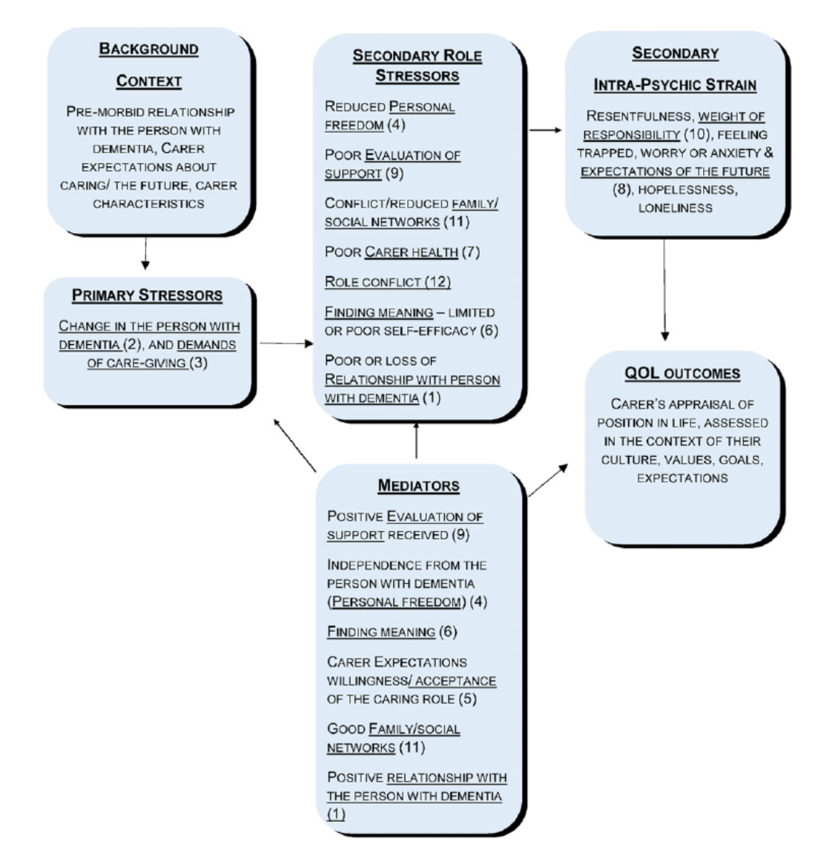
(Daley et al., 2018; adapted from Pearlin, Mullan, Semple, & Skaff, 1990)
Daley, et al. (2018) conducted research and developed a theoretical framework consistent with previous findings from Vellone, Piras, Teallucci, Zichi Cohen (2008), regarding factors that worsened quality of life, such as concern about the future, the person with dementia’s illness trajectory, and caregiver stress. Factors associated with improved caregiver quality of life identified by the researchers included phenomena such as good health, freedom, psychological wellbeing, independence from the patient, and additional caregiving help (Vellone, et al., 2008). Daley, et al.’s (2018) framework offers a new and more positive view of dementia caregiving as it relates explicitly to caregiver quality of life. This framework offers new useful ways of conceptualizing and potentially impacting the quality-of -life experience of caregivers for people with dementia.
Researcher’s Positionality
Kuhn (2012) points out that good scientists seek to “discover the relation between rules, paradigms, and normal science” within a historical frame and “accepted rules” (p.43). Hostetler (2005) asserts that “good education research is a matter not only of sound procedures but also of beneficial aims and results” (p. 16). Concern for the wellbeing of others is vital to protecting research participants from unnecessary harm, and to focus research efforts on topics that meaningfully impact the lives of older adults in society. What makes good or bad research is a complex subject. Guba (1990) asserts that ‘good research’ struggles between the “inquirer and inquired into,” making the connection between individual researcher and the research being investigated (p.20). Well-executed science continues towards revolution as a way to maintain and modify community structures, to codify group obligations, as models of functional solutions, ways to answer nagging problems, and as exemplars for future scientific advancement and revolution (Kuhn, 2012). For a research statement to be “genuine,” it must exist in a conclusively verifiable context (Popper, 1959, p.504). Popper’s appreciation for deductive logic and theory falsifiability aligns with this researcher’s views, as not all empirical scientific statements are ‘conclusively decidable’ and therefore, either verification or falsification is at times able to be falsifiable without inductive inference (Popper, 1959). In sum, this researcher’s positionality seeks to work within the frame of accepted science with the intention to verify or confirm false the potential for a multidisciplinary cognitive support clinic to impact the caregiver for the person with dementia’s quality of life experience.
Purpose of the Study
This quantitative research study seeks to evaluate the impact of a multidisciplinary cognitive support clinic on quality of life among caregivers for people with dementia. The problem identified is that caregivers of people with dementia are known to have decreased quality of life experience compared to similarly aged and gendered caregivers for those without dementia (Välimäki, et al., 2016; Andreakou, et al., 2016). More precise measurement of the QOL experience of the caregiver for the person with dementia will provide valuable information to better guide future interventions within the field of gerontology and other related allied health professions. It is imperative to understand better multidisciplinary cognitive support clinic strategies that can positively influence caregiver QOL, because understanding varied approaches to care can help elucidate the most beneficial multidisciplinary interventions and enhance care outcomes (Zuchella, 2018).
By improving understanding of how a multidisciplinary cognitive support clinic impacts caregivers of persons with dementia, caregiver QOL can be better understood. This focus can contribute to the body of scientific literature that targets the knowledge gaps focused on underserved caregivers for people with dementia. Daley’s Family Caregiver of People with Dementia Quality of Life Conceptual Framework provides a more focused perspective through which caregiver QOL can be further studied.
A purposive sample will be utilized, and a power analysis will be conducted to ensure the sample size is adequate to achieve statistical significance. Participants will be recruited from newly referred patients to a physician-led cognitive support clinic with multiple geographic locations throughout the Northeastern Pennsylvania region.
If unique aspects of the services provided at a cognitive support clinic impact quality of life among caregivers for people with dementia, they should be identified and documented in the scientific literature. Results from this study can serve as a mechanism to focus on how educators, gerontologists, neurologists, psychiatrists, psychologists, primary care providers, nurses, social workers, occupational therapists, and physical therapists, among others, address the needs of and ability of caregivers of older adults with dementia to move towards improved QOL.
Research Questions and Hypotheses
Research Questions
Given the converging factors of a rapidly aging population, an increase in older adults diagnosed with dementia, and an ever-increasing need for caregiving, society must support caregivers in their efforts. Particular focus must be given to caregiver quality of life, and emerging multidisciplinary collaborative care opportunities through further study examining these factors. The proposed research study has the potential to identify aspects of caregiver QOL that are impacted by the caregiving process, which can potentially advance the ability to inform more optimal planned strategies to address the needs of the caregiver for the person with dementia.

Central Research Question
R1: What impact does participation in a multidisciplinary cognitive clinic have on the overall experience of quality of life among caregivers for people with dementia?
H0: Multidisciplinary cognitive clinic support will not positively affect overall quality of life experience among caregivers for people with dementia.
H1: Participation in a multidisciplinary cognitive clinic will positively and statistically significantly affect overall quality of life experience among caregivers for people with dementia.
Additional Research Questions
R2: What impact does participation in a multidisciplinary cognitive clinic
have on each of the five dementia caregivers’ quality of life subdomains (meeting personal needs, caregiver wellbeing, caregiver-patient relationships, confidence in the future, and feeling supported)?
H0: Participation in a multidisciplinary cognitive clinic will not positively and statistically significantly affect one or more quality of life subdomains for caregivers of people with dementia.

H1: Participation in a multidisciplinary cognitive clinic will positively and statistically significantly affect one or more quality of life subdomains for caregivers of people with dementia.

Rationale for Methodology

This quantitative study design will employ a pre-test post-test design. Quality of life subdomains will be correlated to independent variables from the demographic information and information obtained from the Brown et al. (2019) Carers of Dementia Quality of Life instrument (C-DEMQOL). QOL among caregivers for people with dementia will be analyzed in consideration of services received from a behavioral neurologist-led multidisciplinary dementia care clinic. The C-DEMQOL tool was developed for use in quantitative analysis and provides a useful contemporary reliable and valid measure intended for quantitative research studies.
Definition of the Terms
Dementia – For the purposes of this study, the more common term ‘dementia’ will be used to describe what is now classified in the Diagnostic and Statistical Manual of the American Psychological Association as a ‘major neurocognitive disorder’ (DSM-5, 2013 pp. 602-603). A diagnosis of dementia must involve evidence of and informed concern due to substantial declines in cognitive performance. (602-603). The cognitive performance issues should be verified by reliable testing, known to interfere with activities of daily living, and are not due to delirium or another mental disorder (pp. 602-603).
Older adult – For the purposes of this study, an older adult will be defined as an individual with a chronological age of 65 years or greater (WHO, 2002).
Quality of life (QOL) – The World Health Organization (1999) defines quality of life as “…an individual’s perception of their position in life in the context of the culture and value systems in which they live and in relation to their goals, expectations, standards, and concerns” (p. 3). Additional elements of this concept include incorporating “the person’s physical health, psychological state, level of independence, social relationships, personal beliefs, and their relationship to salient features of their environment” (p.3). This definition will be used for the purposes of this study.
Unpaid caregiver – For the purposes of this study, unpaid caregiver will be defined as someone who receives no payment for caring for a person with dementia. They typically assist with activities of daily living (ADL’s) like dressing and bathing, instrumental activities of daily living (iADL’s) like providing transportation, shopping, or bill paying assistance (Alzheimer’s, 2018, p. 31). The unpaid caregiver may also provide assistance with decision-making and social-emotional support as well (p.31). Caregiver and ‘carer’ should be considered synonymous for the purposes of this study.
Limitations of the Study
A methodological limitation of the study is the use of a purposive sample, which will limit generalizability due to variance in geographic factors underlying the problem being examined. Another limitation of the study is that other theories could have informed the theoretical foundation of the study, as caregiver QOL can involve numerous factors. However, careful consideration has been applied to appropriate theory selection, and the Family Caregiver of People with Dementia Quality of Life Conceptual Framework has been selected for goodness of fit. A topical specific limitation to this study is that there is not currently a sufficient amount of information about the efficacy of a multidisciplinary dementia care clinic model vs. standard care in community practice. The use of participant self-reported data can also introduce the potential for response bias (Rosenman, Tennekoon, & Hill, 2011). An additional potential limitation could be the development of survey fatigue, which could occur if subject enthusiasm or responsiveness decrease (Lavrakas, 2008).
Summary and Organization of the Remainder of the Study
Caregivers for people with dementia represent a large proportion of caregivers in general, and as many as 30% deferred their own care needs to provide care to dementia care recipients (Alzheimer’s, 2018). Many unpaid caregivers had no choice but to provide caregiving assistance due to financial reasons (Gaugler, et al., 2016). As compared to the general population, these unpaid caregivers disproportionately “report that their health is fair to poor,” thus enhancing the potential to decrease quality of life (QOL) (p. 41). Increased caregiving responsibilities can impact numerous domains of quality of life that will be measured, including use of external support, employment status, use of medication therapies, utilization of medical care, and impact on numerous factors associated with wellbeing (Thomas et al., 2006). This chapter provides an introduction to this study, including the background of the study, research literature gaps; problem statement and significance; theoretical foundations; researcher’s positionality, purpose, research questions and hypothesis, the rationale for the methodology, and definition of terms. Chapter two will describe the existing body of scientific literature and opportunities to address identified gaps as informed by the Family Caregiver of People with Dementia Quality of Life Conceptual Framework in the planned research.
Chapter 2: Literature Review
Introduction to the Chapter and Background to the Problem
Unpaid caregivers provided an estimated 18.4 billion hours of unpaid care support to individuals with Alzheimer’s Disease and related dementias (ADRD) (Alzheimer’s Association, 2018). Vocational problems faced by caregivers of people with dementia included nearly half not working, and of those who did work, 57% arrived to work late or had to leave early, and 18% were forced to reduce their work hours. Ten percent of caregivers had to give up work entirely (Alzheimer’s, 2018). Other significant burdens that caregivers face include the rapid need for caregiving assistance without training, deferring one’s own care needs to care for the person with dementia, reporting a worse than average health status, reduced participation in social activities, risk of injury, and experiencing symptoms of psychological distress, such as depression, anxiety, or nervousness (Carmeli, 2014; Alzheimer’s, 2018; van der Lee et al., 2014). Multidisciplinary cognitive support interventions can be a valuable mechanism to address the “complex range of cognitive, physical, social, and emotional problems associated with dementia” by reducing caregiver distress and helping caregivers of people with dementia make coordinated connections to additional resources (Grand, 2011, p. 126).
Quality of life is defined as a person’s perceived life context, inclusive “of culture and value systems in which they live and in relation to their goals, expectations, standards, and concerns” (WHO, 1999, p.3). Other critical components of this definition include “the person’s physical health, psychological state, level of independence, social relationships, personal beliefs, and their relationship to salient features of their environment” (p.3). Over the next several decades, the population of older adults will continue to increase and is estimated to make up nearly 25% of the population, of which about 5% will be over 85 years of age (Federal Interagency Forum on Aging-Related Statistics, 2016). Because the burden of Alzheimer’s and other related dementias (ADRD) will impact nearly 14 million adults, or about 3.5% of the U.S. population, by 2060, associated healthcare costs will likely reach $1 trillion by 2050 (Matthews et al., 2018; He, Goodkind, & Kowal, 2016). Compounding this problem is the fact that nearly half of caregivers who are caring for people with ADRD’s who often require significant dependent caregiving assistance, and these needs increase as the individual’s status continues to decline due to the progressive nature of ADRD’s (Alzheimer’s, 2018, Albert & Freeman, 2010, Andreakou et al., 2016; Farina et al., 2017; Välimäki et al., 2016).
Chapter two will provide a theoretical foundation for this quantitative study, as viewed through the Family Carer of People with Dementia Quality of Life Conceptual Framework lens. This theoretical framework will be explored in relation to the existing literature and central research question, which seeks to assess what impact participation in a multidisciplinary cognitive support clinic has on the overall experience of quality of life among caregivers for people with dementia. This chapter will also describe what is known about dementia as a societal problem, the quality of life experience of caregivers of people with dementia, including factors that influence caregiver quality of life, caregiver burden, and how multidisciplinary dementia care can mediate quality of life for caregivers of people with dementia.
Theoretical Foundations and/or Conceptual Framework
As introduced in Chapter 1, Daley et al. (2018) offer an emerging conceptual framework focused on understanding and improving the quality of life of family caregivers for people with dementia. The Family Carer of People with Dementia Quality of Life Conceptual Framework was adapted from Pearlin, Mullan, Semple, & Skaff’s (1990) Conceptual Framework of Alzheimer’s Caregivers’ Stress (Daley et al., 2018). Daley et al. (2018) conducted a qualitative research study that focused on identifying “specific role-related factors that influence Quality of Life (QOL) from the perspective of family carers of people with dementia” (p. 80). The views of and changes within the caregivers’ relationship with the dementia care recipient, the context or situation in which caregiving takes place, and external factors that can be perceived as either helpful or unhelpful were identified as necessary to understand caregiver quality of life (Daley et al., 2018). These three categories, person with dementia factors, carer (caregiver) factors, and external factors, represent major concepts in this framework (Daley et al., 2018).
Relationship of Concepts Within the Framework
Person with dementia factors include the relationship with the dementia care recipient, change in the person with dementia, such as personality changes and memory loss, and the demands of caregiving (Daley et al., 2018). Caregiver factors include personal freedom, acceptance of the caregiving role, finding meaning in caregiving, the caregiver’s health, and expectations of the future (Daley et al., 2018). External factors and environment include the caregiver’s evaluation of support, perceptions of the burden of responsibility, family and social network, and role conflict (Daley et al., 2018). The authors developed a framework based on these key concepts and an existing stress process model previously developed by Pearlin, Mullen, Semple, and Skaff (1990). Daley et al. (2018) adjusted their model to facilitate a better understanding of quality of life among family caregivers of people with dementia.
The model begins with the background context, which includes the pre-diagnosis relationship between the caregiver and the dementia care recipient, in addition to the expectations about care, the future, and the individual characteristics of the caregiver (Daley et al., 2018) (see figure 1). The background context influences the impact that primary stressors have on the caregiver (Daley et al., 2018). Examples of primary stressors include a change in the baseline of the person with dementia and the demands of caregiving (Daley et al., 2018). Caregivers typically experience secondary role stressors such as, “reduced personal freedom, poor evaluation of support, conflict and/or reduced family social networks, poor caregiver health, role conflict, difficulty in finding meaning, and decline or loss of relationship in the person with dementia” (p. 84). Caregivers frequently experience secondary intra-psychic strain such as “resentfulness, weight of responsibility, feeling trapped, worry or anxiety, and expectations of the future, hopelessness, and loneliness” (p. 84). These factors impact QOL outcomes, including the caregiver’s “appraisal of position in life, assessed in the context of their culture, values, goals, [and] expectations” (p. 84). While these factors are negative in nature, they may be positively affected by the following mediating factors: “positive evaluation of support received, personal freedom, finding meaning, acceptance of the caregiving role, good family social networks, and a positive relationship with the person with dementia” (p. 84).
Daley et al.’s (2018) research and framework were consistent with previous findings from Vellone, Piras, Teallucci, Zichi Cohen (2008) regarding factors that worsened quality of life, such as concern about the future, the person with dementia’s illness trajectory, and caregiver stress. Factors associated with improved caregiver quality of life identified by the researchers included phenomena such as good health, freedom, psychological wellbeing, independence from the patient, and additional caregiving help (Vellone et al., 2008). Daley et al.’s (2018) framework offers a new and more positive view of dementia caregiving as it relates specifically to caregiver quality of life. This framework offers new and valuable ways of conceptualizing and potentially impacting the quality of life experience of caregivers for people with dementia.
Review of the Literature
Dementia as a Societal Problem
Pickett et al. (2017) completed compelling research that sought to clarify opportunities to improve dementia research, prevention, diagnosis, and intervention. The interventional component of this work identified goals focused on improving conditions for families seeking support for dementia-related care needs and the quality and inclusivity of health-related and social support (Pickett et al., 2017). The method utilized was an iterative consensus methodology model, and included the Alzheimer’s Society, key United Kingdom (UK) clinicians, and researchers with expertise in dementia, representative members of funding sources, individuals with dementia, and their caregivers. The participant make-up also included individuals with dementia and their caregivers (n=8), members of the Alzheimer’s Society Research Network (n=15), and Alzheimer’s Society Annual Conference participants (n=40). Subsequent to numerous structured meetings, an online survey sought perspectives from participants leading to goals and recommendations (Picket et al., 2017). A key component of the research recommendations centered on ways to “address inequalities in access and outcomes between people affected by dementia” (Picket et al., 2017, p. 902).
Daviglus et al. (2010) documented the National Institute for Health’s (NIH) state-of-the-science conference statement on preventing Alzheimer’s Disease and cognitive decline. The authors discuss that chronological age is the most significant risk factor for developing Alzheimer’s Disease (Daviglus et al., 2010). Stephan et al. (2018) evaluated the relationship between subjective age and incident dementia with data from the National Health and Aging Trends Study (NHATS) and found that problem of dementia has notable personal and societal implications, including “functional limitations, disability, and mortality which generate substantial social and economic costs” (Stephan et al., 2018, p.1). These burdens also have the potential to impact the quality-of-life experience of caregivers of people with dementia.
In the US Census Bureau’s most recent projections of the population's size and composition through 2060, it is estimated that the US population will increase to 98 million by 2060 (Colby & Ortman, 2014). It is projected that by 2030, one out of five Americans will be over the age of 65, and by 2044, “more than half of all Americans are projected to belong to a minority group (any group other than non-Hispanic White alone); and by 2060, nearly one in five of the nation’s total population is projected to be foreign-born” (p. 25). Because of the relationship between age and experience of dementia, and rapid and diverse increases in aging projected through 2060, further scientific inquiry must be undertaken to evaluate strategies to effectively respond to the public health challenges related to the needs of people with dementia and their caregivers.
Caregiver Burden
Early work on caregiver burden referred to the impact of care provision for another with a health problem that could impact the caregiver’s self-esteem, health, financial status, schedule, and emotional wellbeing (Given et al., 1992; Stommel et al., 1993). Sherwood et al. (2014) noted that caregiver burden also involves direct care components, such as grooming, bathing, feeding, medication administration, and indirect and instrumental care activities, such as transportation to appointments, shopping, and financial management. The authors also describe caregivers as an emotional support resource to care recipients (Sherwood et al., 2014).
In a quasi-experimental research study, Lin, Shih, & Ku (2019) evaluated the mediating role of caregiving hours on activities of daily living function and neuropsychiatric symptoms of people with dementia and caregiver burden. The authors noted that when the individual with dementia who relies on assistance from the caregiver experienced neuropsychiatric behaviors, the individual with dementia’s ability to perform activities of daily living (ADL’s) was decreased, and the experience of burden by caregivers was increased (Lin, Shih, & Ku, 2019). The authors collected data from the Zarit Burden Interview (ZBI) (2001) caregiver self-assessment of burden questionnaire in two waves; with an (N=186), characteristics of persons with dementia and caregiver dyads were recorded pre and post caregiver intervention (Lin, Shih, & Ku, 2019). Linear regression was used to determine the changes in dementia care recipient basic activities of daily living and caregiver experience of burden. The authors observed that caregiving hours in basic activities of daily living impacted the relationship between dementia care recipient basic activity of daily living function and caregiver burden (effect =-0.0137, 95% Bootstrap CI= -0.0379, -0.0003), but did not find similar mediating effects on neuropsychiatric behaviors and caregiver burden (Lin, Shih, & Ku, 2019). Overall, the authors found that “respite care services for caregivers of people with dementia should target services that assist persons with dementia’s basic activities of daily living” (p.25).
A three-year longitudinal study was recently conducted that examined the burden of caregivers of people with dementia (Connors, et al., 2019). Patients and caregiver proxies (n= 779) were selected for the three-year study if they attended a memory clinic for support and received clearance from an institutional ethics committee. An observational study design was utilized. Assessments for the study were conducted by clinical specialists, nurses, or psychologists with research training. The Zarit Burden Interview (ZBI) (22 items) was to assess caregiver burden. The Clinical Dementia Rating Scale (CDR) (0-18 range) was used to determine the severity of dementia experienced by the care recipient. The Mini-Mental Status Exam (MMSE) (0-30 range) was used to assess cognitive function. The Functional Autonomy Measurement System (SMAF) (-87 -0 range) was used to determine functional performance. The Neuropsychiatric Inventory (NPI) (0-144 range) evaluated mental health-related domains, and the level of service involvement was evaluated at each measurement with questions developed by the authors (Connors, et al., 2019).
The longitudinal data were explored linear mixed models with normally distrusted intercepts and random effects for time” (Connors, et al., 2019, p. 252). A regression analysis was used to determine the relationship between time and level of service utilization. The study found that at the start of the intervention, nearly 48% of caregivers experienced caregiver burden at baseline. By year three, this group increased to nearly 57%, or an approximate 9% increase in caregiver burden. Numerous characteristics of the individuals with dementia, including “greater neuropsychiatric symptoms, lower functional ability, fewer medications, lack of driving ability—and female sex of caregivers were associated with greater burden” (Connors, et al., 2019, p. 250). The study's limits include the use of a convenience sample, a lack of documented age or educational data demographic information, and the authors described not assessing positive aspects as another limitation of their research (Connors, et al., 2019).
Another research update and critical analysis of burden experienced by caregivers of people with dementia was written by Sheung -Tak’s (2017). The vital contribution of this article is the observation of neuropsychiatric symptoms that are predictors of caregiver burden. These behaviors include “agitation, aggression, disinhibition, followed by delusions and mood disturbance” Sheung -Tak, 2017, p. 63). The author further elaborates on a limitation of this article, and the current body of available scientific research, which notes the need to examine individual neuropsychiatric symptoms related to caregiver burden, especially depressive symptoms. Another limitation of the existing literature identified in this article includes the need for researchers to examine caregiver burden for caregivers of people with dementia beyond Alzheimer’s Disease type dementia alone (Sheung -Tak, 2017).
Dementia Caregiver Quality of Life
Developing a better understanding of quality of life for dementia caregivers is essential to their ability to carry out their caregiving duties successfully. Andreakou, Papadopoulos, Panagiotakos, & Niakas (2016) conducted an observational research study targeted at better understanding health-related quality of life for caregivers of people with Alzheimer’s Disease. The study describes and assesses connections between demographic factors and emotional issues in relation to time spent caregiving. The study population included 180 family member caregivers of people with dementia in Athens, Greece, who were recruited for the project. The number of subjects who agreed to participate was 155 participants (86.1%) (Andreakou, Papadopoulos, Panagiotakos, & Niakas, 2016). “The selected sample size of 155 participants is considered adequate to evaluate multiple adjusted effect size measures equal to 0.14 at 5% significance level of two-sided hypotheses, achieving statistical power equal to 95% (sample size calculations were performed in G-Power v 3.0.10, Kiel, Germany) (p. 2).
Multiple instruments were utilized to collect the data described. The first instrument used was a structured demographic questionnaire. The second instrument utilized was the Zung Depressive Rating Scale (ZDRS), a globally well-regarded self-rated depression scale that evaluates affective, psychological, and physical symptoms that mediate depression. The scale ranges from 20-80, and scores are evaluated and described as one of four categories, including normal range, mild, moderate, or severe depression (Fountoulakis, Lacovides, Samolis, Kleanthous, Kaprinis, Kaprinis, & Bech, 2001; Zung, 1965). The other instrument used in this study was the Health-Related Quality of Life (HRQoL) Short Form 36 Health Survey (SF-36), which is a global instrument designed for research in clinical care environments, policy development, and general population research (Brazier, Ratcliffe, Tsuchiya, Salomon, 2007; Grassi & Nucera, 2010). The SF-36 is divided into two categories, including a physical component summary (PCS) and a mental component summary (MCS) (Grassi & Nucera, 2010). Correlations were assessed using a linear correlation coefficient Spearman rho. Physical and mental health were evaluated in relationship to ZDRS, PCS, and MCS scores (Andreakou, Papadopoulos, Panagiotakos, & Niakas, 2016). Results demonstrated that caring for a relative with Alzheimer’s Dementia resulted in more negative HRQoL scores and had a negative impact on the experience of depression, which was especially prevalent later in the dementia disease progression (Andreakou, Papadopoulos, Panagiotakos, & Niakas, 2016). Lower HRQoL scores were attributed to “greater frequency of care, through living with the patient, (being) in poor financial situations, and with the existence of a chronic illness.” (p.1). Limitations of the study include the inability to develop conclusive inferences, comparisons relied on an “epidemiological reference population,” the population was limited to a limited metropolitan region of Greece, and caregivers entered the caregiving role at different points in time and disease progression (p. 10). While the study has the limits mentioned above, since there was limited prior research in this area, it has moved the knowledge of the health-related quality of life for caregivers of people with dementia in a positive direction.
Välimakä, Martikainen, Hongisto, Väätäinen, Sintonen, and Koivisto (2016) conducted a longitudinal research study evaluating the long-term effects of Alzheimer’s Disease on family caregiver quality of life. Two hundred thirty-six caregiver-patient dyads were studied over three years and were compared to a representative national sample of Finish persons totaling 7,964 people. The mean age of caregivers was 65.7 years of age, with the predominant caregiver gender being identified as female ( 67%) and two-thirds of caregivers residing in the same home. Caregivers were recruited within a few months or less of a family member receiving an Alzheimer’s Dementia diagnosis and were required to have daily care interactions with the dementia care recipients, whom all resided in the community during the study. Several instruments were used to collect data, including the Mini-Mental Status Exam (MMSE) with a 0-30 score range, which was used to measure cognitive performance, the Alzheimer’s Disease Cooperative Study Activities of Daily Living Scale (ADCS-ADL) with a 0-78 score range, which was used to assess functional performance, and the 15D (15 dimensions) and visual analog scale (VAS) with a 0-100 scale, which were used to Measure caregiver HRQoL. Välimakä, Martikainen, Hongisto, Väätäinen, Sintonen, and Koivisto (2016). Välimakä, Martikainen, Hongisto, Väätäinen, Sintonen, and Koivisto (2016).
A longitudinal design was employed also using linear regression with a generalized estimating equation (GEE) model. A two-tailed t-test allowed the researchers to determine the significance of group variance. The outcomes of this study similarly asserted claims by Andreakou, Papadopoulos, Panagiotakos, & Niakas (2016) that found HRQoL to be lower than non-caregivers in the control group. Another important finding was a significant association (p < 0.05) between aspects of caregiver HRQoL, which were decreased related to problems with mobility and depression. While HRQoL decreased earlier than expected in the study, the severity of Alzheimer’s Dementia did not have as significant an impact on caregiver outcomes as was suspected Välimakä, Martikainen, Hongisto, Väätäinen, Sintonen, and Koivisto (2016).
A systematic review of factors associated with caregivers of people with dementia was conducted to learn what factors impact quality of life (Farina et al., 2017). The terms “carers,” “dementia,” “family,” and “quality of life” were queried, and results “were synthesized inductively, grouping factors associated with carer QOL into themes” (Farina et al., 2017, p. 572). A total of 909 abstracts were identified, and a subsequent screening process was undertaken and involved lateral searches and evaluation of the quality of the abstracts (Farina et al., 2017). The quantitative and qualitative studies analyzed modifiable factors that can impact caregiver quality of life (Farina et al., 2017). Then 41 studies (n=5339) were synthesized after screening, and ten key themes were identified, and included “…1) demographics, 2) carer-patient relationship, 3) dementia characteristics, 4) demands of caring, 5) carer health, 6) carer emotional wellbeing, 7) support received, 8) carer independence, 9) carer self-efficacy, 10) future” (Farina et al., 2017, p. 575-576). It was identified that caregivers of people with dementia are the most significant practical, personal, economic supports for the population of people experiencing dementia (Farina et al., 2017).
Belle et al. (2006) authored a germinal study entitled Enhancing the Quality of Life of Dementia Caregivers from Different Ethnic and Racial Groups. The study was a randomized control trial, and participants were comprised of 212 caregivers of people with dementia who identified as Hispanic or Latino, 219 people who identified as white or Caucasian, and 211 black or African-American (n= 642). Caregivers were required to be a relative of the person with dementia they were caring for, the care recipient had to have a dementia diagnosis and have an MMSE score greater than 0, and if the score was higher than 23, physician approval was required for inclusion in the study. The research was conducted with community residing caregivers in five cities within the United States. Five instruments were used to collect respondent information in this study. Depression was measured using the Center for Epidemiologic Studies Depression Scale (CES-D), which has 30 items monitored by a safety board to track symptoms of clinical depression. Caregiver burden was assessed using the Zarit Caregiver Burden Interview, which has a 44 point scale. The study’s authors developed their own 11 question self-care assessment, three-item social support assessment, and three-question problem behavior assessment (Belle, et al., 2006).
Caregivers of people with dementia that represented each of the racial or ethnic groups were randomly assigned as members of the intervention or control groups. The intervention concentrated on domains of depression, burden, self-care, social support, and care recipient behavioral presentation via “12 in-home and telephone sessions over six months” as compared to the control group, which had “2 brief “check-in” telephone calls during the 6-month intervention” (Belle, et al., 2006, p. 727). For the main outcomes, a generalized estimating equation (GEE) model with robust sandwich SE’s was conducted to assess for statistical significance compared to the control group. Linear regression was used to test the effects of the intervention on changes for each separate domain. A Pearson chi-square was utilized to evaluate racial and ethnic group differences. A logistic regression model was used to determine relationships between depression from baseline to 6-months post-treatment, which controlled for initial differences in depression by racial and ethnic groups. (Belle, et al., 2006). Results included notably improved quality of life perception compared to the control group among Hispanic or Latino and white or Caucasian participants (P < 0.001 and P = 0.037, respectively). African American caregivers who were spouses also had a noticeable improvement in quality of life (P =0.003). Participants from the intervention group reported a lower rate of depression in caregivers (12.6% vs. 22.7%; P = 0.001). Institutionalization was measured at the six-month point with no statistically significant findings (Belle, et al., 2006). The primary limitations reported in the study were that only one follow-up assessment was implemented at 6-months and the inclusion of “heterogeneous cultures and ethnicities into a single group,” and that some ethnic groups were excluded (p. 2).
These studies consistently show that depression (Andreakou, Papadopoulos, Panagiotakos, & Niakas, 2016; Välimakä, Martikainen, Hongisto, Väätäinen, Sintonen, and Koivisto, 2016), heavy care needs and decreased mobility in persons with dementia (Välimakä, Martikainen, Hongisto, Väätäinen, Sintonen, and Koivisto, 2016) financial stress, and chronic illness (Andreakou, Papadopoulos, Panagiotakos, & Niakas, 2016) all have been found to contribute to caregiver burden.
Quinn, Nelis, Martyr, Morris, Victor, and Clareon (2020) conducted a cross-sectional research study entitled Caregiver influences on “living well” for people with dementia: Findings from the IDEAL study. Study participants included 1,283 informal caregivers (time-point 1) and 1,283 caregivers of people with dementia from the IDEAL cohort study. The researchers utilized eight instruments. The first instrument was a demographic instrument created by the research team. The next instrument was the 15 item Relative Stress Scale that measures caregiver perceptions of stress related to caregiving. Two questions were taken from Balducci, et al.’s social restriction scale. The two-question Caregiving Competence scale evaluates the perceived adequacy of caregiving support provided. The Positive Aspects of Caregiving scale (9 items) looks at the perceived sense of reward or satisfaction related to caregiving. One item was taken from the caregiving subscale of the Carers for Older People in Europe index on 4 point Likert scale. The Quality of Life-Alzheimer’s Disease Measure (PwD-QoL) (13 items) was used to measure the quality of life among persons with dementia. The Satisfaction with Life Scale (PwD-SwLS) is a 5 item scale that measures perceived life satisfaction. The final tool used in the study was the World Health Organization-Five Well-Being Index, which assesses wellbeing over several weeks Quinn, Nelis, Martyr, Morris, Victor, Clareon (2020).
The study included data from time point 1 of the IDEAL study, which included people with dementia and caregivers. A multivariate statistical model was implemented to evaluate perceived caregiving experience, quality of life, life satisfaction, and wellbeing.
Where higher caregiver stress was reported, lower quality of life was reported by care recipients with dementia (–1.98, 95% CI: –2.98, –1.07). This stress was also associated with increased perceptions of social restrictions (–2.04; 95% CI: –2.94, -1.14) and decreased caregiving competence (–2.01; 95% CI: –2.95, –1.06). Satisfaction with life and wellbeing were similarly mediated by caregiver stress (Quinn, Nelis, Martyr, Morris, Victor, Clareon, 2020). Furthermore, “positive aspects of caregiving and coping were not associated with outcomes for the person with dementia” (p. 1505).
Since higher caregiver stress has been associated with decreased quality of life in care recipients and increased caregiver stress has also been linked to decreased caregiving competence (Quinn, Nelis, Martyr, Morris, Victor, Clareon, 2020), there is a critical need for emerging models of care that will mediate these factors for caregivers of persons with dementia. The potential to improve upon outcomes for people with dementia and their caregivers remain important targets of further investigation.
Multidisciplinary Dementia Care
Multiple sources indicate the problems inherent with the current U.S. dementia care system. Lack of access to services and qualified providers, fragmentation of care, duplication of services, and inefficiency in resource utilization, coupled with a rapidly aging population and increased rate of dementia, have created pressing public health and policy challenges. New solutions are approaches are needed to tackle these significant issues. Multi-disciplinary dementia care models offer a potential solution to address many of these critical problems (Choi & Pak, 2006; Grand et al., 2011; Zucchella et al., 2018).
Dawson, Bowes, Kelly, Velzke, Ward (2015) completed a systematic literature review focused on evaluating evidence of what works to support and sustain care at home for people with dementia. The systematic literature review utilized CINAHL, IngentaConnect, Medline, ProQuest, PsychINFO, and Web of Science databases, and initial searches were “followed by a structured review and full-text evaluation process, the latter using methodology appropriate quality assessment criteria drawing on established protocols” (Dawson, Bowes, Kelly, Velzke, Ward, 2015, p. 1). A PRISMA 2009 checklist was utilized as a part of the systematic review process, and the review was conducted by a team of trained readers who evaluated full texts and reported findings in a predetermined reporting format utilizing the ‘Stirling literature review proforma,’ which allows “the capture of bibliographic and content-related data and facilitates a research-design specific quality assessment of reviewed texts” (p. 4).
Samples of the texts were read twice to promote interviewer reliability. There were 131 publications reviewed, of which 56 were found to meet ‘high’ quality standards, 62 were found to meet ‘medium’ quality standards, and 13 were deemed to be of ‘low’ quality. Weaknesses in a number of publications were found to methodological flaws or failure to produce sufficient evidence. Themes that emerged in the literature as a result of the content analysis included potential benefits of self-directed support for people with dementia, the need for improved agile response solutions and multidisciplinary approaches to care, integrating technology supports for people with dementia, and the need for better low or no cost supportive care (Dawson, Bowes, Kelly, Velzke, Ward, 2015). Several critical limitations within the existing body of literature included a lack of focus on support for caregivers, the need for more multifactorial interventions with better focus, and the need to better link well designed evidenced-informed services for healthcare practitioners, people living with dementia, and their caregivers (Dawson, Bowes, Kelly, Velzke, Ward, 2015). This study will provide increased focus on the impact of multidisciplinary clinic support on caregivers of people with dementia. In addition to determining if a multidisciplinary care approach is helpful to this demographic group, the study will also assess the impact of the multidisciplinary clinic model on meeting personal needs, caregiver wellbeing, caregiver-patient relationships, confidence in the future, and feeling supported.
Zucchella, et al. (2018) completed a narrative review of multidisciplinary nonpharmacological treatment (NPT) approaches to Alzheimer’s Disease and dementia. The PubMed and Cochrane systematic review databases were searched across an eight-year timeframe for a targeted keyword list. The bibliographies of selected articles were also reviewed to identify other appropriate publications. Because of the similarity of some NPT interventions and varied outcomes reported in the literature, the narrative review approach was chosen to provide a valuable resource for clinicians concerning NPT approaches currently being utilized. The work yielded a range of NPT interventions that can be utilized in multidisciplinary care contexts. These included exercise and motor rehabilitation, cognitive interventions, nonpharmacological management of behavioral and psychological symptoms of dementia, occupational therapy, psychological therapy, multicomponent and multidimensional strategies, complementary and alternative medicine, aromatherapy, music therapy, art therapy, massage and touch, novel technologies, ICT, assistive devices and domotics, virtual reality and gaming, and telemedicine (Zucchella, et al., 2018). NPT “encompasses a wide range of interventions to improve patients’ symptoms, reduce the stress of caregivers, and ameliorate the environment” (p. 2). NPT is often utilized in multidisciplinary care environments, but the evidence for use is still emerging. A research study targeted at studying the effects of a stepwise multidisciplinary intervention for problem behaviors in people with advanced dementia found that in facility residing residents, training caregiving staff on behavioral management strategies resulted in fewer behaviors and psychotropic medication use (Pieper, et al., 2016). Such behavioral management educational strategies can be considered as part of a multidisciplinary care approach. Zuchella, et al. (2018) describe the study's primary limitation is its narrative design but assert a systematic review was not possible due to the substantial number of studies available on NPT, AD, and dementia.
A noteworthy pragmatic trial currently underway is the Dementia Care (D-CARE) study funded by the Patient-Centered Outcomes Research Institute and the National Institute on Aging, examining the efficacy and cost-effectiveness of multidisciplinary health system vs. community-based usual dementia care (Reuben, et al., 2020). The study targets an existing multidisciplinary dementia care literature gap, understanding community-based dementia care compared to health system-based care vs. routine care. The study is designed as a pragmatic randomized superiority trial with various research arms. The study is being conducted in clinical and academic healthcare settings within the United States. There are a total of 2,150 English and/or Spanish-speaking care recipient and caregiver dyads. Over an eighteen-month period, participant dyads will receive one of the three intervention arms. The dyads will be surveyed with instruments including the Neuropsychiatric Inventory Questionnaire (NPI-Q) Severity and Modified Caregiver Strain Index scales (Reuben, et al., 2020). Several outcomes anticipated by the study are to understand better caregiver confidence and unmet needs, caregiver depression, perceived caregiver burden, and positive aspects of caregiving.
Summary & Integration
Dementia is a significant societal problem, and both people with dementia and their caregivers face inequalities in disparate access to necessary supports (Picket et al., 2017). Unpaid caregivers provide many billions of dollars of unpaid care each year, face vocational challenges, poorer health, and psychological distress (Alzheimer’s Association, 2018; Carmeli, 2014; van der Lee et al., 2014). With projected growth of the U.S. population in general, and one out of five Americans expected to be over age 65 by 2044, the public health challenges caused by dementia and dementia caregiving, there is still significant work to be done to reduce the impact of this public health problem (Colby & Ortman, 2014). The burden of caregivers is significant, and worsens over time spent caregiving (Connors, et al., 2019). We must work to better understand factors that influence caregiver quality of life, so that caregivers can carry out caregiving responsibilities well (Andreakou, Papadopoulos, Panagiotakos, & Niakas, 2016). Because caregiver stress is an important mediator of caregiver satisfaction with life and wellbeing, caregiver stress management strategies must continue to be prioritized (Quinn, Nelis, Martyr, Morris, Victor, Clareon, 2020).
Multi-disciplinary dementia care models can positively impact dementia care recipients and their caregivers (Dawson, Bowes, Kelly, Velzke, Ward (2015; Reuben, 2020). These individuals represent a significant proportion of the aging population in the U.S. (Gaugler, James, Johns, Scholtz & Weuve, 2016; U.S. Census Bureau, 2020). From a policy and health care financing perspective, multi-disciplinary dementia care can be an essential healthcare aim to replace outdated and inefficient models of dementia care that are not adequately serving society well (Alzheimer’s, 2018; Reikert, et al. 2014). The impact of these new models on health care quality, access to care, health care costs, and improved equity for those needing this essential care remain important aims for contemporary gerontology and related allied health professions.
Chapter 3: Methodology
Introduction
Alzheimer’s Dementia (AD) and other dementia subtypes have a notable impact on unpaid caregivers of people with dementia due to the many and complex responsibilities of caregiving for people with dementia (Carmeli, 2014). Dementia is a terminal disease process with an average life expectancy of four to ten years, and involves long-term caregiving responsibilities, which can pose a significant burden to caregivers (Xie et al., 2008). Those who meet diagnostic criteria for a dementia diagnosis can often require dependent care from family caregivers or community-based healthcare facilities (Albert & Freeman, 2010). The impact that these care needs have on caregivers of persons with dementia is substantial. The high stress of caregiving provides further support for the proposed research on caregiver quality of life. The use of a pre-test post-test design utilized in this study will allow the investigator to evaluate the impact of multidisciplinary dementia care on caregiver quality of life.
This chapter will discuss the research methodology, research design, study population and sample selection, instrumentation, and validity and reliability related to the research study. Data collection procedures, data analysis procedures, ethical considerations, limitations will also be addressed. In support of clarifying the rationale for the chosen methodology, the statement of the problem that inspired the research and chosen research questions will be reviewed.
Statement of the Problem
It is not known to what extent a multidisciplinary cognitive support clinic approach to care impacts the experience of quality of life among caregivers of people with dementia remains unclear. This quantitative research study seeks to investigate the impact of a multidisciplinary cognitive support clinic on caregiver qualify of life. The study may also advance knowledge about specific challenges and benefits to quality of life among caregivers of people with dementia. Since one in three older adults will be diagnosed with Alzheimer’s disease or other dementias, it remains imperative that we better understand what supports unpaid caregivers of people with dementia require (Alzheimer’s, 2018, p.25). Older adults diagnosed with dementia typically need dependent care from family members who function as caregivers or from a healthcare facility. Of the unpaid caregiving that people with dementia receive, 83% “comes from family members, friends, or other unpaid caregivers” with close to half of all caregiving in the United States being provided to people with a dementia diagnosis (Alzheimer’s, 2018, p.31). Of those providing dementia related caregiving support, approximately 70% of caregivers reside with the care recipient, and about one-fourth of caregivers also concurrently provide care to a minor under the age of 18 (Alzheimer’s, 2018, p.32). Because these caregivers are known to face challenges that impact quality of life compared to similar caregivers for people without dementia, and the caregiving burden for a person with dementia is progressive and can last for a number of years, further inquiry in this are remains an important aim for contemporary gerontology and allied health sciences (Välimäki, et al., 2016, p. 687).
Research Questions and Hypotheses
Multiple intersecting aspects of a swiftly aging population, combined with increasing numbers of older adults who experience a dementia diagnosis, and the related need for caregivers highlight the increased societal support needed by caregivers of people with dementia. The ways that multidisciplinary care impacts caregiver quality of life remains an especially important component of this societal challenge. The proposed research study will seek to identify how a multidisciplinary clinic support resource can impact quality of life among caregivers of people with dementia and could potentially advance opportunities to develop better planned strategies to potentially address the needs of caregivers of people with dementia. In the future.
Central Research Question
R1: What impact does participation in a multidisciplinary cognitive clinic have on the overall experience of quality of life among caregivers for people with dementia?
H0: Multidisciplinary cognitive clinic support will not positively affect overall quality of life experience among caregivers for people with dementia.
H1: Participation in a multidisciplinary cognitive clinic will positively and statistically significantly affect overall quality of life experience among caregivers for people with dementia.
Additional Research Question
R2: What impact does participation in a multidisciplinary cognitive clinic
have on each of the five dementia caregivers’ quality of life subdomains (meeting personal needs, caregiver wellbeing, caregiver-patient relationships, confidence in the future, and feeling supported)?

H0: Participation in a multidisciplinary cognitive clinic will not positively and statistically significantly affect one or more quality of life subdomains for caregivers of people with dementia.

H1: Participation in a multidisciplinary cognitive clinic will positively and statistically significantly affect one or more quality of life subdomains for caregivers of people with dementia.

Research Methodology
A pre-test, post-test design will be used in this quantitative study. Data obtained from the Carers of Dementia Quality of Life instrument (C-DEMQOL)(Brown et al., 2019) and demographic information will be correlated with Quality of Life subdomains. Pre-experimental one-group, pre-test post-test research design can be used with a modest sample size in support of establishing evidence for future related subsequent experimental research (Thyer, 2010).
Research Design
To investigate the impact of a multidisciplinary care clinic on dementia caregiver quality of life, a quantitative study was chosen as the most appropriate research strategy for this purpose. Research data utilized for this study includes caregiver demographic data and the Carers of Dementia Quality of Life instrument (C-DEMOQOL) data, including its five subscales (Brown, et al. 2019). This quantitative study design will utilize a pre-posttest design (Creswell & Gutterman, 2019). Pre-experimental pre-test post-test design allows researchers to begin to conduct preliminary research that can be later built upon with further experimental research studies once feasibility has been established (Thyer, 2010). The varied conditions within the group are intentionally assigned by the researcher since groups are not able to be created for the purposes of conducting an experiment; therefore, subjects are not randomized (Plano-Clark & Creswell 2015).
Study Population and Sample Selection
Participants will be recruited from newly referred patients to a physician-led cognitive support clinic with multiple geographic locations throughout the Northeastern Pennsylvania region. Staff will notify the researcher of clinic referrals so that they can be invited to participate. Interested parties can also reach out to the researcher directly via the contact information provided on the informational flier provided at the clinic. A purposive sample will be utilized. Inclusion criteria include subjects must be 18 years of age or older. They must be able to read and speak English. Participants must be the caregiver of an individual receiving services at the cognitive support clinic. Exclusion criteria include individuals less than 18 years of age. Individuals who cannot read and speak English will be excluded from participation. Individuals who are not the caregiver of an individual receiving services at the cognitive support clinic will also be excluded from participation.
A power analysis was conducted utilizing G*Power software. The power analysis combined statistical factors, subject matter factors, and other requirements to ensure the sample size would be adequate to achieve statistical significance. Using a medium effect size (Cohen’s d=0.5), the analysis identified a total sample size of 27 being necessary to achieve sufficient power using a medium effect size (Cohen’s d= 0.5). The researcher plans to oversample by twenty percent, increasing the planned sample size to 33, in order to ensure that missing cases and incomplete data do not negatively impact on statistical analysis and study outcomes resulting in a goal of 33 for sample size. See figure two below for further details concerning the G*Power calculation (see Figure 2 below).

Figure 2
Power Analysis
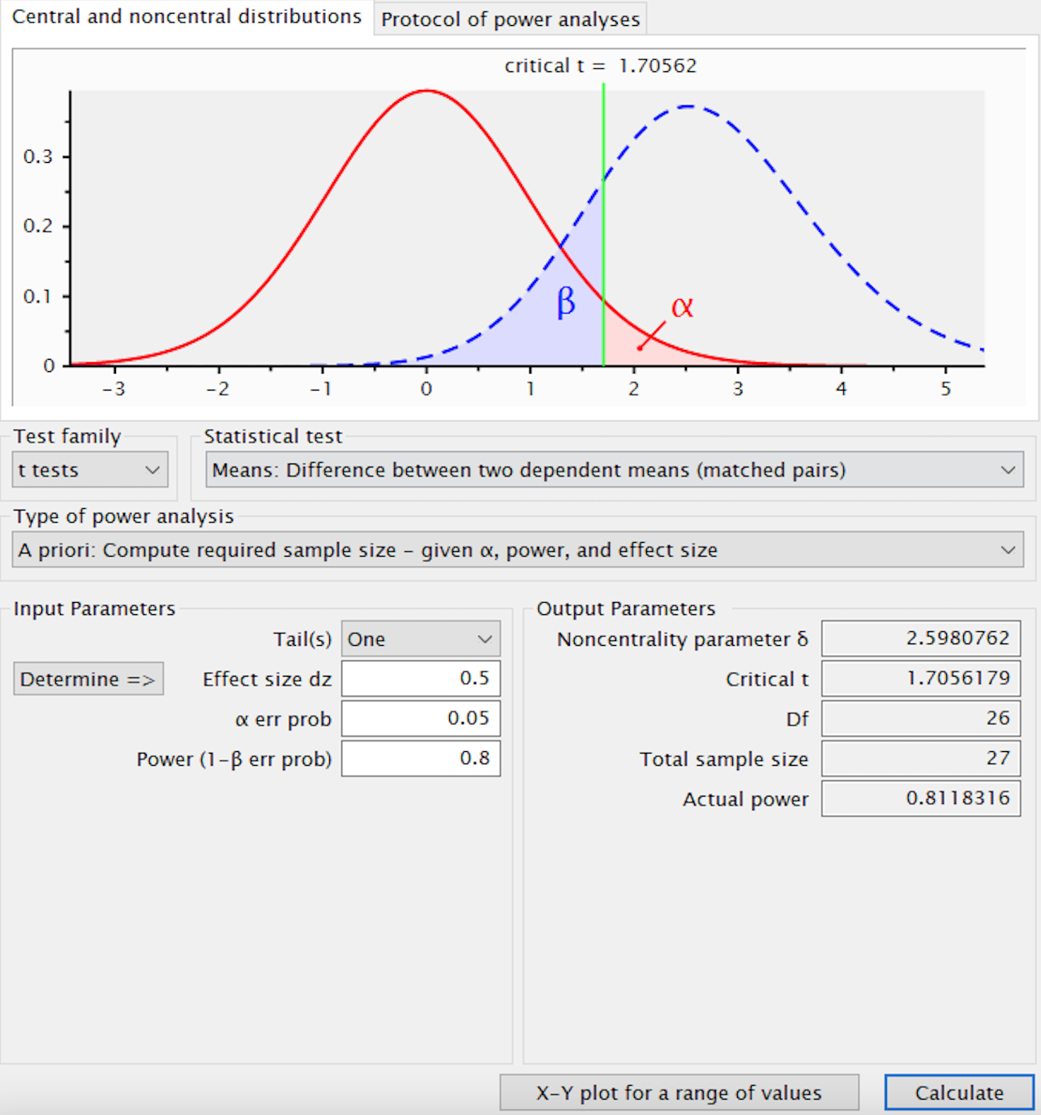
Instrumentation
The Carers of Dementia Quality of Life Instrument (C-DEMQOL) was chosen after an extensive literature review was conducted for goodness of fit. Prior to the development of the C-DEMQOL tool, caregiver quality of life was previously measured with “generic instruments, or by considering psychopathology, burden and the challenges of caregiving” (Brown, et al., 2019, p. 2300). Manthrope & Bowling (2016) and Page, et al. (2017) conducted related systematic reviews. The former systematic review identified that while generic quality of life measurement tools widely exist, they were found have insufficient ‘social relevance’ and lacked emphasis on issues related to dementia specifically (Manthrope & Bowling, 2016). The two dementia specific caregiving tools that were identified and focused on quality of life were The Alzheimer’s Carers’ Quality of Life Instrument (ACQLI) and The Caregiver Quality of Life (CGQOL). These tools were found to be overly broad, or inappropriate for use in typical relevant settings, or posed other relevant limitations (Page, et al. 2017). For example, the AQOLI tool failed to determine how “an overall poor QOL score is driven by burden, anxiety, or poor relationships with the person with dementia, despite inclusion of these issues at an item level” and the CGQOL was burdensome with over 80 items in its inventory and the tool has limited validity related to factor analysis only being conducted at the subscale level, therefore “lacking confirmation of dimensionality at the item level” (Brown, et al., 2019, p. 2300). After further considering these measurement tool weaknesses and limitations, the investigator continued to seek out a better tool. This search led to the Carers of Dementia Quality of Life Instrument (C-DEMQOL) which is discussed in further detail below.
Carers of Dementia Quality of Life Instrument (C-DEMQOL)
Due to the limitations of the many existing generic instruments and the ACQOLI and CGOL dementia specific tools, Brown and colleagues developed the Carers of Dementia Quality of Life Instrument (C-DEMQOL) to be specific to caregivers of people with dementia, and to be appropriate for a wide array of caregiving contexts and types of dementia (Brown, et al. 2019). The instrument’s authors determined that C-DEMQOL had to offer “(i) comprehensive coverage of issues related to the QOL of family carers of people with dementia; (ii) accurate measurement of overall QOL and subdomains; and (iii) usability and efficiency, limiting cognitive, emotional, and time burdens on carers” (Brown, et al. 2019, p. 2300).The detailed psychometric properties of the C-DEMQOL and the process by which the tool was validated and tested were clearly outlined by the authors and will be discussed below (Brown et al., 2019).
The development of the C-DEMQOL instrument occurred in five stages (Brown, et al., 2019). The first stage focused on identifying factors that were relevant to family caregiver’s quality of life. This occurred by first conducting a systematic literature review and then exploratory factor analysis (EFA) was undertaken with ordinal variables. A “parallel analysis based on polychoric correlations of item responses favoured a five factor solution” (Brown, et al., 2019, p. 2302). The final five QOL domains were identified as carer-patient relationship, carer wellbeing, meeting personal needs, confidence in the future, and feeling supported. A field trial and psychometric evaluation were then conducted. A bifactor model was utilized to confirm useability, validity, and reliability of the C-DEMQOL tool (Brown, et al., 2019). The model-based coefficient omega (omega hierarchical (omegaH or ω_{h}) and omega hierarchical subscale (omegaHS or ω_{hs}) was utilized to evaluate subdomain and total C-DEMQOL scores (Brown, et al., 2019). Proportional reduction in mean squared error was predicated on score totals (PRMSE_{TOT}) for determining suitability of subdomain score reporting (Brown, et al., 2019). When omega assessed subscale reliability exceeded PRMSE_{TOT}, scores derived from subscales provided information in addition to overall Quality of Life (QOL) and therefore can be reported (Brown, et al., 2019). Scored constructs each had Standard Errors of Measurement (SE_{M}) calculated from “respective omega coefficients and scale standard deviations. SE_{M} are more useful in practice than reliability coefficients as they are not population-dependent, and are direct measures of the error margin around observed scores” (Brown, et al., 2019, p. 2304). (See Table 1).
Reliability & Validity
Construct validity refers to the process of validating a group of interrelated variables (Salkind, 2014). “Construct reliability/replicability was assessed as the proportion of variability in general and subdomain factors explainable by respective indicator variables, using the index H, with values around 0.7 and above indicating the latent factor is reliably represented by its indicators. Reliable factors can be used with confidence in latent variable models” (Brown et al., 2019, p. 2304). Convergent and discriminant validity were determined for both subdomain and total scores. This was done via identifying correlations “with the validation measures, using the standard multi-trait multi-method framework” (Brown et al., 2019, p. 2304). Convergent validity examines the level of consistency and agreement between measurement outcomes, which represent a specific construct (Teddlie & Tashakkori, 2009) . “Convergent validity was summarized as the average correlation with external scales measuring conceptually similar constructs, and discriminant validity was summarized as the average correlation with conceptually dissimilar constructs” (Brown et al., 2019, p. 2304).
The “sociodemographic characteristics of the field test carer sample” (Brown et al., 2019, p. 2310) used in the development and psychometric testing and analysis of the C-DEMQOL tool were selected for use in the demographic questionnaire based on congruency and relevance. These included carer sex, carer age, carer race and ethnicity, carer employment status, career relationship to the person with dementia, co-residence with the person with dementia, and type of dementia. A question on caregiver educational level of attainment was also added to the demographic questionnaire as it was also deemed relevant to the study.

Table 1
Conceptual map of qualitative themes, factors associated with carer QOL and constructs measured in an existing condition-specific measure (CGQOL) and in C-DEMQOL (initial and empirically confirmed)
Factors Associated with Carer QOL | Constructs measured in CGOL | 12 themes from qualitative interviews | C-DEMQOL 7 working constructs | C-DEMQOL 5 final constructs
Carer-patient relationship |  | 1. Relationship with the person with dementia | Relationship with the person with dementia | Carer-patient relationship
Carer self-efficacy | Benefits of caregiving  Spirituality & faith | 5. Acceptance of the caring role  6. Finding meaning | Carer role (appraisal of own, self-efficacy, acceptance)
Dementia characteristics | Caregiver Feelings | 2. [feelings about] Change in the person with dementia | Carer health (physical and emotional) | Carer wellbeing
Carer health; Carer emotional wellbeing |  | 7. Carer health (physical and emotional) |  | Meeting personal needs
Demands of caregiving | Assistance with IADL’s/ADL’s; Demands of caregiving  Role limitations due to caregiving | 3. Demands of caregiving  12 .Role conflict | Carer responsibilities (demands of caregiving burden)
Carer Independence | Personal time | 4. Personal freedom | Carer personal needs (need for personal time and space)
Future | Worry | 8. Expectations of the future | Feelings about the future | Confidence in the future
Support received | Family Interaction | 9. Evaluation of support  10. Weight of responsibility  11. Family & social networks | Carer support (from family, professionals and community) | Feeling supported
(Brown et al., 2019)
Data Collection Procedures
To ensure privacy and confidentiality of research subjects, all data will be maintained in a locked file cabinet in the primary investigator’s (PI) office with access limited to the PI. Further, all data will be de-identified. A master coding list will be created and maintained in a separate locked file away from individual subject survey responses. Subjects will be assigned a subject number, which will also be used to on demographic surveys and to match pre-test and post-test data on the C-DEMQOL surveys.
Following obtaining the informed consent, subjects will be asked to complete the 30-item C-DEMQOL survey instrument and a nine-item demographic questionnaire. These data will be collected through telephonic interview. The principal researcher or trained research assistants who have completed CITII research training and who is familiar with the C-DEMQOL tool will collect the face-to-face data and/or telephonic interviews. The principal investigator will collect telephonic interviews. This method of data collection was deemed to be the most easily accessible and user-friendly methods of obtaining survey data and are consistent with policies of the health system where the research is being conducted. The clinic physician’s office was consulted to verify this approach would be best. Both the PI and trained research assistant will both use the C-DEMQOL Measurement of Quality of Life in Family Carers with People with Dementia Instruction Manual for Administration.
Recruitment Procedures
After obtaining institutional review board (IRB) approval, the following recruitment procedures will be instituted. A flier describing the proposed research will be posted in clinic waiting rooms and examination rooms. The approved flier will provide a description of the project with contact information for the researcher. The flier will also detail inclusion and exclusion criteria, risks and benefits of participation, and incentives. Due to COVID-19 pandemic restrictions regarding physical access to patients for research necessitate the clinic’s CITI certified behavioral neurology clinicians to initially explain the study, answer questions from potential subjects, and finally obtain informed consent for those who wish to participate. If required by the institution and the IRB, Health Information and Portability and Accountability Act (HIPPA) consent will also be obtained. A hard copy of the informed consent and HIPPA consent will be provided to subjects. Clinic staff have agreed to participate in the recruitment of subjects for the study. Behavioral neurology clinic staff will receive training and standard operating procedures for recruitment via a web-based or telephonic training session conducted by the researcher. Clinic staff have agreed to assist with recruitment of new clinic patients.
Data Analysis Procedures
The Statistical Package for Social Sciences (SPSS) version 26 will be used to analyze study data. A syntax file for coding C-DEMQOL data was published by Brown, et al. 2019, which is compatible with SPSS. Raw C-DEMQOL scores will be analyzed using the C-DEMQOL Score Calculator (V1.0, Beta Version). Following the cleaning and screening of the data, statistical analysis, including a paired samples t-test and descriptive statistics will also be conducted. Descriptive statistics will provide data about the study population demographics and will provide context regarding the study population. These data will be analyzed using measure of central tendency. Measures of central tendency include mean, median, and mode, each of which differentiates information concerning scoring distributions (Cresswell & Gutterman, 2019).
Since the study will use a pretest/posttest and it includes hypothesis testing, a paired samples t-test will be utilized. A paired samples t-test is used to determine whether the mean difference between two sets of observations is zero (Yim, Nahm, Hahn, & Park, 2010). Paired samples t-tests measure each subject twice, which yields pairs of observations. This statistical method is commonly used in repeated measure designs, which is consistent with the design of this study (Yim, Nahm, Hahn, & Park, 2010). Utilization of the paired t-test will allow the researcher to evaluate any differences between pretest and post-test C-DEMQOL composite scores and the five dementia caregivers’ quality of life subscale scores including meeting personal needs, caregiver wellbeing, caregiver-patient relationships, confidence in the future, and feeling supported, in order to determine if there any differences in composite or subdomain scores that may occur over time following exposure to the multidisciplinary cognitive clinic intervention.
The researcher expects to learn more about the impact a multidisciplinary cognitive clinic has on perceptions of overall quality of life for caregivers of people with dementia. Demographic variables will be used to determine to what extent the sample represents the overall population and provide context to the data (see Table 2 below).
Table 2
Variables for Study
Variables | Measurement Tool | Scale
Caregiver Age | Demographic Tool | Continuous
Caregiver Sex | Demographic Tool | Categorical
Caregiver Ethnicity | Demographic Tool | Categorical
Employment Status | Demographic Tool | Categorical
Caregiver Relationship to Person with Dementia | Demographic Tool | Categorical
Co-Residence with Person with Dementia | Demographic Tool | Categorical
Type of Dementia | Demographic Tool | Categorical
Caregiver Quality of Life | C-DEMQOL | Continuous

Ethical Considerations
Institutional Review Board (IRB) approval will be obtained prior to beginning the study. In accordance with the Department of Health and Human Services (DHHS) Federal research guidelines 45 CFR 46, all research subjects will be notified of their rights related to participation in the research study (OHRP, 2021). These rights include the ability to withdraw from the study at any time without fear of coercion or negative impact on medical care, the ability to have data removed from the study and appropriately disposed of, the right to confidentiality and secure storage and deidentification of study data. Subjects who complete both the pretest and post test data collection will have their names entered into a drawing for a chance to win a $250 Amazon gift card. Subjects who do not complete all requirements of the study will be ineligible to participate in the drawing.
In accordance with 45 CFR 46, all signed informed consent forms will be sent to the dissertation chair via certified mail, where they will be maintained for a period of three years and then shredded. All signed HIPPA forms will also be sent to the dissertation chair via certified mail. HIPPA forms will be retained for a period of 6 years, after which time the forms will also be shredded.
Limitations
Delimitations of the study are as follows. This study covers the extent to which a multidisciplinary cognitive support clinic intervention could impact the quality of life experience of unpaid caregivers of people with dementia. This study does not cover the quality-of-life experience of people with dementia themselves. This study is limited to new caregivers of only newly referred patients to a physician-led cognitive support clinic with multiple geographic locations throughout the Northeastern Pennsylvania region. This study focuses specifically on the extent to which a physician-led multidisciplinary clinic intervention impacts quality of life of caregivers of people with dementia.
Because a purposive convenience sample will be used for this research study, generalizability will be limited. Due to the pre-test post-test research design, randomization and a control group will not be used. Participation may also be limited by what insurance products the clinic accepts. Only two clinic locations in North-Eastern Pennsylvania will participate in this study. Since the researcher only speaks English and no translation services will be available, subjects will be limited to those who can read, write, and speak English. Patients who have already received care at the clinic will also be excluded from participation in the study.
Summary
This chapter outlined key aspects of research methodology, which will be utilized for this study. An evaluation of the reliability and validity testing of the selected measurement instruments that will be utilized for this study was provided.

References
Adler, G., Lawrence, B. M., Ounpraseuth, S. T., & Asghar-Ali, A. A. (2015). A survey on dementia training needs among staff at community-based outpatient clinics. Educational Gerontology, 41(12), 903-915. https://doi-org.misericordia.idm.oclc.org/10.1080/03601277.2015.1071549
Albert, S. M., & Freedman, V. A. (2010). Public health and aging: Maximizing function and wellbeing (2ndedition, pp.1-34). Springer Publishing Company
Alzheimer’s Association. 2018 Alzheimer’s Disease Facts and Figures. Alzheimer’s Dementia 2018, 14(3).
Andreakou, M. I., Papadopoulos, A. A., Panagiotakos, D. B., & Niakas, D. (2016). Assessment of health-related quality of life for caregivers of Alzheimer’s disease patients. International Journal of Alzheimer’s Disease, 1-7. https://doi.org/10.1155/2016/921368
Appadurai, A. (1996). Modernity at large: Cultural dimensions of globalization. University of Minnesota Press.
Belle, S. H. (2006). Enhancing the Quality of Life of Dementia Caregivers from Different Ethnic or Racial Groups. Annals of Internal Medicine, 145(10), 727. https://doi.org/10.7326/0003-4819-145-10-200611210-00005
Brady B. A., Tucker C. M., Alfino P. A., Tarrant D. G., Finlayson G. C., 1997. An investigation of factors associated with fluid adherence among hemodialysis patients: A self-efficacy theory based approach. Annals of Behavioral Medicine 19, 339-343.
Brazier, J., Ratcliffe, J., Saloman, J., & Tsuchiya, A. (2016). Measuring and Valuing Health Benefits for Economic Evaluation. Oxford Medicine Online. https://doi.org/10.1093/med/9780198725923.001.0001
Brown, A., Page, T. E., Daley, S., Farina, N. Basset, T., Livingston, G., Budgett, J. Gallaher, L., Feeney, Y., Murray, J., Bowling, A., Knapp, M., & Banerjee, S. (2019). Measuring the quality of life of family carers with people with dementia: Development and validation of C-DEMQOL, Quality of Life Research, 28(8), 2299-2310. https://doi-org.misericordia.idm.oclc.org/10.1007/s11136-019-02186-w
Carmeli, E. (2014). The invisibles: Unpaid caregivers of the elderly. Frontiers in Public Health, 2(91), 1st ser., 1-3. https://doi.org/10.3389/fpub.2014.0091
Colby, S. L., & Ortman, J. M. (2014). Projections of the Size and Composition of the U.S. Population: 2014-2060 (25-1143). U.S. Census Bureau.
Connors, M. H., Seeher, K., Teixeira‐Pinto, A., Woodward, M., Ames, D., & Brodaty, H. (2019). Dementia and caregiver burden: A three‐year longitudinal study. International Journal of Geriatric Psychiatry, 35(2), 250–258. https://doi.org/10.1002/gps.5244
Crellin, N. E., Orrell, M., Mcdermott, O., & Charlesworth, G. (2014). Self-efficacy and health-related quality of life in family carers of people with dementia: A systematic review. Aging & Mental Health, 18(8), 954-969. https://doi-org.misericordia.idm.oclc.org/10.1080/13607863.2014.915921
Creswell, J., & Guertterman, T. (2019). Educational research planning, conducting, and evaluating quantitative and qualitative research (6th edition). Pearson.
Daley, S., Murray, J., Farina, N., Page, T.E., Brown, A., Basset, T., Livingston, G., Bowling, A., & Knapp, M. (2018). Understanding the quality of life of family carers of people with dementia: Development of a new conceptual framework. International Journal of Geriatric Psychiatry 34(1), 79-86. https://doi-org.misericordia.idm.oclc.org/10.1002/gps.4990
Daviglus, M. L. (2010). National institutes of Health STATE-OF-THE-SCIENCE Conference Statement: Preventing Alzheimer disease and cognitive decline. Annals of Internal Medicine, 153(3), 176. https://www.acpjournals.org/doi/10.7326/0003-4819-153-3-201008030-00260
Dawson, A., Bowes, A., Kelly, F., Velzke, K., & Ward, R. (2015). Evidence of what works to support and sustain care at home for people with dementia: a literature review with a systematic approach. BMC Geriatrics, 15(59). https://doi.org/10.1186/s12877-015-0053-9
Diagnostic and statistical manual of mental disorders: DSM-5 (591-645). (2013). American Psychiatric Association.
Elder, G. H., Jr. (1994, March). Time, Human Agency, and Social Change: Perspectives on the Life Course. Social Psychology Quarterly, 57(1), 4-15.
Farina, N., Page, T. E., Daley, S., Brown, A., Bowling, A., Basset, T., Livingston, G., Knapp, M. Murray, J., Banerjee, S. (2017). Factors associated with the quality of life of family carers of people with dementia: A systematic review. Alzheimer’s & Dementia, 13(5), 572-581. https://doi-org.misericordia.id.oclc.org/10.1016/j.jalz.2016.12.010
Federal Interagency Forum on Aging-Related Statistics. (2016). Older Americans 2016: Key indicators of wellbeing. Federal Interagency Forum on Aging-Related Statistics. U.S. Government Printing Office.
Fountoulakis, K. N., lacovides, A., Samolis, S., Kleanthous, S., Kaprinis, S. G., Kaprinis, G. S., & Bech, P. (2001). Reliability, validity and psychometric properties of the Greek translation of the Zung depression rating scale. BMC Psychiatry, 1(1). https://doi.org/10.1186/1471-244x-1-6
Gaugler, J., James, B., Johnson, T., Scholz, K., & Weuve, J. (2016). 2016 Alzheimer’s Facts & Figures [PDF file]. Retrieved from https://www.alz.org/documents_custom/2016-facts-and-figures.pdf
Given, C. W., Given, B., Stommel, M., Collins, C., King, S., & Franklin, S. (1992). The caregiver reaction assessment (CRA) for caregivers to persons with chronic physical and mental impairments. Research in Nursing and Health, 15(4), 271–283.
Grand, J. H., Caspar, S., & Macdonald, S. W. (2011). Clinical features and multidisciplinary approaches to dementia care. Journal of Multidisciplinary Healthcare, 4, 125-47.
Grassi, M., & Nucera, A. (2010). Dimensionality and Summary Measures of the SF-36 v1.6: Comparison of Scale- and Item-Based Approach Across ECRHS II Adults Population. Value in Health, 13(4), 469–478. https://doi.org/10.1111/j.1524-4733.2009.00684.x
Guba, E.G. (1990). The paradigm dialogue. SAGE publications, 17-27.
He, W., Goodkind, D., & Kowal, P. (2016). An Aging World: 2015 (Rep. No. International Population Reports, P95/16-1). Retrieved from http://www.census.gov/content/dam/Census/library/publications/2016/demo/p95-16-1.pdf
Hostetler, K. (2005). What is “good” education research? Educational Researcher, 34(6), 16-21.
Hughes, S. L., Stolte, E., 7 Smith-Ray, R. (2016). Theoretical foundations for designing and implementing health promotion programs. In V. L. Bengtson, & R. A. Settersten (Eds.), Handbook of Theories of Aging (463-478). Springer Publishing Company.
Jennings, L. A., Ramirez, K. D., Hays, R. D., Wenger, N. S., & Reuben, D. B. (2018). Personalized goal attainment in dementia care: Measuring what persons with dementia and their caregivers want. Journal of the American Geriatrics Society, 66(11), 2120-2127. https://doi-org.misericordia.idm.oclc.org/10.111/jgs.15541
Kuhn, T. S. (2012). The structure of scientific revolutions, (4th edition). The University of Chicago Press.
Lin, C. Y., Shih, P. Y., & Ku, L. E. (2019). Activities of daily living function and neuropsychiatric symptoms of people with dementia and caregiver burden: The mediating role of caregiving hours. Archives of Gerontology and Geriatrics, 81, 25–30. https://doi.org/10.1016/j.archger.2018.11.009
Office for Human Research Protections (OHRP). (2021, June 16). 45 CFR 46. HHS.gov. Retrieved October 11, 2021, from https://www.hhs.gov/ohrp/regulations-and-policy/regulations/45-cfr-46/index.html.
Manthrope, J., & Bowling, A. (2016). Quality of life measures for carers for people with dementia : measurement issues, gaps in research and promising paths. Research, Policy and Planning, 31, 163–178.
Matthews, K. A., Xu, W., Gaglioti, A. H., Holt, J. B., Croft, J. B., Mack, D., & McGuire, L. C. (2019). Racial and ethnic estimates of Alzheimer’s disease and related dementias in the United States (2015-2060) in adults aged ≥65 years. Alzheimer’s & Dementia : The Journal of the Alzheimer’s Association, 15(1), 17–24. https://doi.org/10.1016/j.jalz.2018.06.3063
Maydeu-Olivares, A., & Coffman, D. L. (2006). Random intercept item factor analysis. Psychological Methods, 11(4), 344–362. https://doi.org/10.1037/1082-989x.11.4.344
Odenheimer, G., Borson, S., Sanders, A. E., Swain-Eng, R. J., Kyomen, H. H., Tierney, S., . . . Johnson, J. (2013). Quality improvement in neurology: Dementia management quality measures (Executive Summary). American Journal of Occupational Therapy,67(6), 704-710. https://doi.org/10.5014/ajot.2013.676004
Papastavrou, E., Andreou, P., Middleton, N., Papacostas, S., & Georgiou, I. K. (2014). Factors associated with quality of life among family members of patients with dementia in Cyprus. International Psychogeriatrics, 26(3), 443–452.
Page, T. E., Farina, N., Brown, A., Daley, S., Bowling, A., Basset, T., Livingston, G., Knapp, M., Murray, J., & Banerjee, S. (2017). Instruments measuring the disease-specific quality of life of family carers of people with neurodegenerative diseases: a systematic review. BMJ Open, 7(3). https://doi.org/10.1136/bmjopen-2016-013611
Pearlin, L.I., Mullan, J.T., Semple, S.J., & Skaff, M.M. (1990). Caregiving and the stress process: An overview of concepts and their measures. The Gerontologist, 30(5).
Pickett, J., Bird, C., Ballard, C., Banerjee, S., Brayne, C., Cowan, K., . . . Walton, C. (2018). A roadmap to advance dementia research in prevention, diagnosis, intervention, and care by 2025. International Journal of Geriatric Psychiatry, 33(7), 900-906. https://doi-org.misericordia.idm.oclc.org/10.1002/gps.4868
Pieper, M. J., Francke, A. L., van der Steen, J. T., Scherder, E. J., Twisk, J. W., Kovach, C. R., & Achterberg, W. P. (2016). Effects of a Stepwise Multidisciplinary Intervention for Challenging Behavior in Advanced Dementia: A Cluster Randomized Controlled Trial. Journal of the American Geriatrics Society, 64(2), 261–269. https://doi.org/10.1111/jgs.13868
Popper, K. R. (1959). A survey of some fundamental problems. In K. R. Popper, the logic of scientific discovery, (pp. 497-505). Basic Books.
Proposed working definition of an older person in Africa for the MDS Project (2002). Retrieved from https://www.who.int/healthinfo/survey/ageingdefnolder/en/
Quinn, C., Nelis, S. M., Martyr, A., Morris, R. G., Victor, C., & Clare, L. (2019). Caregiver influences on ‘living well’ for people with dementia: Findings from the IDEAL study. Aging & Mental Health, 24(9), 1505–1513. https://doi.org/10.1080/13607863.2019.1602590
Riekert, K. A., Ockene, J. K., & Pbert, L. (2014). Handbook of health behavior change. Springer Publishing Company, LLC.
Reuben, D. B., Gill, T. M., Stevens, A., Williamson, J., Volpi, E., Lichtenstein, M., Jennings, L. A., Tan, Z., Evertson, L., Bass, D., Weitzman, L., Carnie, M., Wilson, N., Araujo, K., Charpentier, P., Meng, C., Greene, E. J., Dziura, J., Liu, J., … Peduzzi, P. (2020). D‐CARE: The Dementia Care Study: Design of a Pragmatic Trial of the Effectiveness and Cost Effectiveness of Health System–Based Versus Community‐Based Dementia Care Versus Usual Dementia Care. Journal of the American Geriatrics Society, 68(11), 2492–2499. https://doi.org/10.1111/jgs.16862
Rosenman, R., Tennekoon, V., & Hill, L. G. (2011). Measuring bias in self-reported data. International journal of behavioural & healthcare research, 2(4), 320–332. https://doi.org/10.1504/IJBHR.2011.043414
Salkind, N. J. (2014). Statistics for people who (think they) hate statistics (5th ed.). SAGE.
Satoh, M., Kida, H., Kawagita, S., Yamazaki, K., Tabei, K., & Tomimoto, H. (2018). Dementia IT screening system (DITS): Practical use of local social resources for early diagnosis of dementia with collaboration between family physicians and dementia specialists. Geriatrics & Gerontology International, 18(4), 599-606. https://doi-org.misericordia.idm.oclc.org//10.1111/ggi.13221
Sherwood P., Given B., Fisher A.H. (2014) Caregiver, Burden. In A.C. Michalos (ed.), Encyclopedia of quality of life and wellbeing research. Springer, Dordrecht. https://doi.org/10.1007/978-94-007-0753-5_280
Stephan, Y., Sutin, A. R., Luchetti, M., & Terracciano, A. (2018). Subjective age and risk of incident dementia: Evidence from the National Health and Aging trends survey. Journal of Psychiatric Research, 100, 1-4. https://doi.org/10.1016/j.jpsychires.2018.20.008
Staekenborg, S.S., Pijnenburg, Y.A., Lemstra, A.W., Scheltens, P. (2016). Dementia and rapid mortality: Who is at risk? J Alzheimers Disease, 53, 135-142.
Stommel, M., Wang, S., Given, C. W. and Given, B. (1992), Focus on psychometrics confirmatory factor analysis (CFA) as a method to assess measurement equivalence. Research in Nursing & Health, 15(5), 399–405. https://doi-org.misericordia.idm.oclc.org/10.1002/nur.4770150508
Tang, W. K., & Chan, C. Y. (2016). Effects of psychosocial interventions on self-efficacy of dementia caregivers: A literature review. International Journal of Geriatric Psychiatry, 31(5), 475–493. https://doi.org/10.1002/gps.4352
Thyer, B. A. (2010). The Handbook of Social Work Research Methods, 2. https://doi.org/10.4135/9781544364902
Teddlie, C., & Tashakkori, A. (2010). Foundations of mixed methods research: Integrating quantitative and qualitative approaches in the social and Behavioral Sciences. SAGE Publ.
Thomas, P., Chantoin-Merlet, S., Hazif-Thomas, C., Belmin, J., Montagne, B., Clément, J., . . . Billon, R. (2002). Complaints of informal caregivers providing home care for dementia patients: the PIXEL study. International Journal of Geriatric Psychiatry, 17(11), 1034-1047. https://doi-org.misericordia.idm.oclc.org/10.1002/gps.746
Thomas, P., Lalloué, F., Preux, P.-M., Hazif-Thomas, C., Pariel, S., Inscale, R., Belmin, J., & Clément, J.-P. (2006). Dementia patients caregivers quality of life: the PIXEL study. International Journal of Geriatric Psychiatry, 21(1), 50–56. https://doi.org/10.1002/gps.1422
Tonga, J. B., Eilertsen, D., Solem, I. K., Arnevik, E. A., Korsnes, M. S., & Ulstein, I. D. (2020). Effect of self-efficacy on quality of life in people with mild cognitive impairment and mild dementia: The mediating roles of depression and anxiety. American Journal of Alzheimer’s Disease & Other Dementias®, 35, 153331751988526.
U.S. Census Bureau (2020). 65 and Older Population Grows Rapidly as Baby Boomers Age. Retrieved August 10, 2020, from https://www.census.gov/newsroom/press-releases/2020/65-older-population-grows.html
U.S. Department of Health and Human Services. (2018). A profile of older adults with dementia and their caregivers. (ASPE Issue Brief). Washington, DC: U.S. Government Printing Office.
Välimäki TH, Martikainen JA, Hongisto K, Väätäinen S, Sintonen H, Koivisto AM. Impact of Alzheimer’s disease on the family caregiver’s long-term quality of life: Results from an ALSOVA follow-up study. Qual Life Res, 25(3), 687-97. https://doi-org.misericordia.idm.oclc.org/10.1007/s11136-015-1100-x
van der Lee, J., Bakker, T. J. E. M., Duivenvoorden, H. J., & Dröes, R.-M. (2014). Multivariate models of subjective caregiver burden in dementia: A systematic review. Ageing Research Reviews, 15, 76-93. https://doi.org/10.1016/j.arr/2014.03.003
Vellone, E., Piras, G., Teallucci, C. Zichi Cohen, M. (2008). Quality of life for caregivers of people with Alzheimer’s disease. Journal of Advanced Nursing, 61(2), 222-231. https://doi-org.misericordia.idm.oclc.org/10.1111/j.1365-2648.2007.04494.x
Wimo, A., Guerchet, M., Ali, G.C., Wu, Y.T., Prina, A.M., Winblad, B., Jönsson, L., Liu, Z., Prince, M. (2017). The worldwide costs of dementia 2015 and comparisons with 2010. Alzheimers Dementia, 13, 1–7.
World Health Organization (1997). WHOQOL Measuring Quality of Life (1-15). Geneva, Switzerland: World Health Organization.
Yim, K. H., Nahm, F. S., Han, K. A., & Park, S. Y. (2010). Analysis of statistical methods and errors in the articles published in the Korean Journal of Pain. The Korean Journal of Pain, 23(1), 35–41. https://doi.org/10.3344/kjp.2010.23.1.35
Zucchella, C., Sinforiani, E., Tamburin, S., Federico, A., Mantovani, E., Bernini, S., Casale, R., & Bartolo, M. (2018). The Multidisciplinary Approach to Alzheimer's Disease and Dementia. A Narrative Review of Non-Pharmacological Treatment. Frontiers in Neurology, 9. https://doi.org/10.3389/fneur.2018.01058
Zung G. W. (1965). A Self-Rating Depression Scale. Archives of General Psychiatry, 12(1), 63. https://doi.org/10.1001/archpsyc.1965.01720310065008

Appendix A
C-DEMQOL Measure of Carer QOL
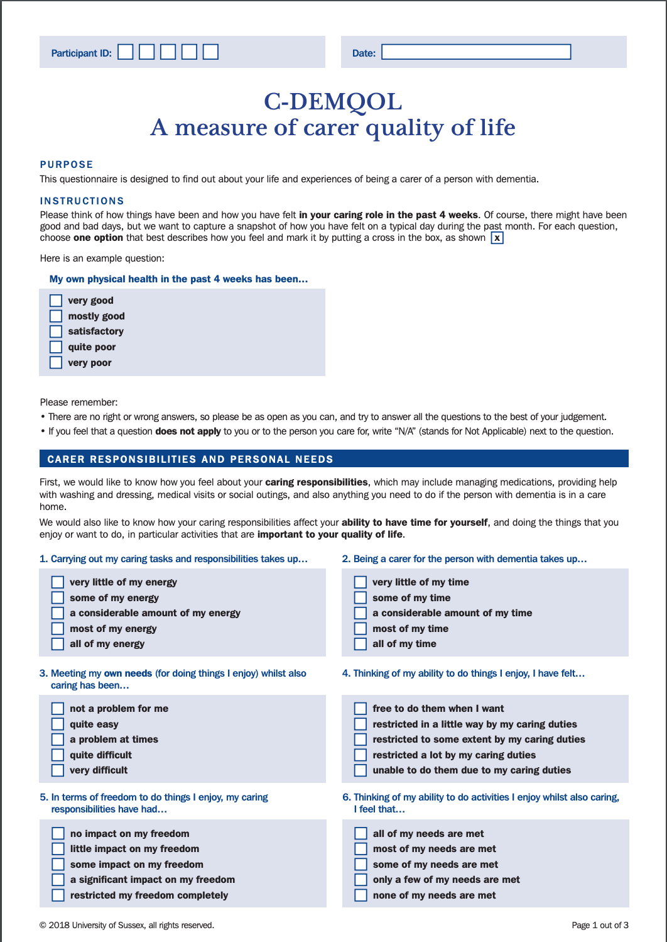
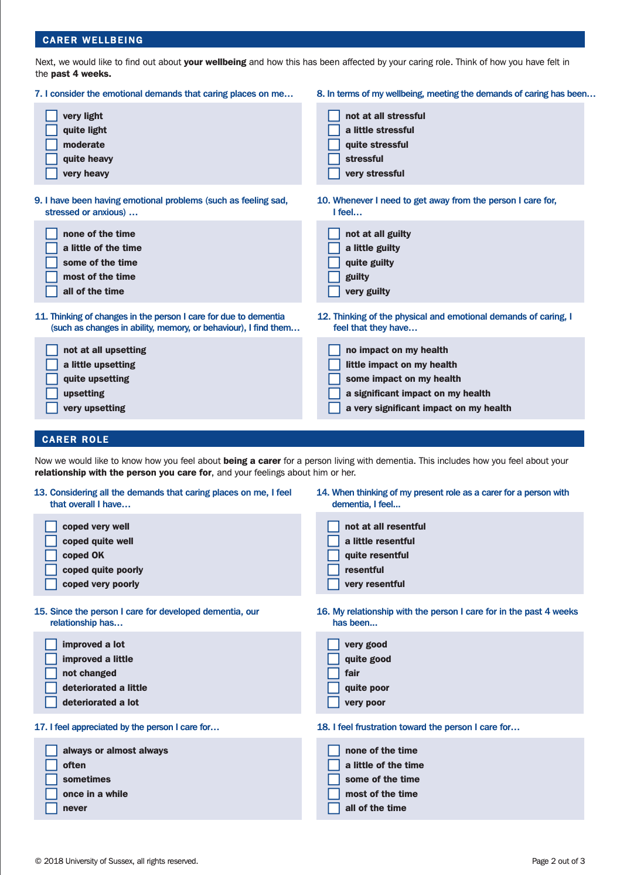

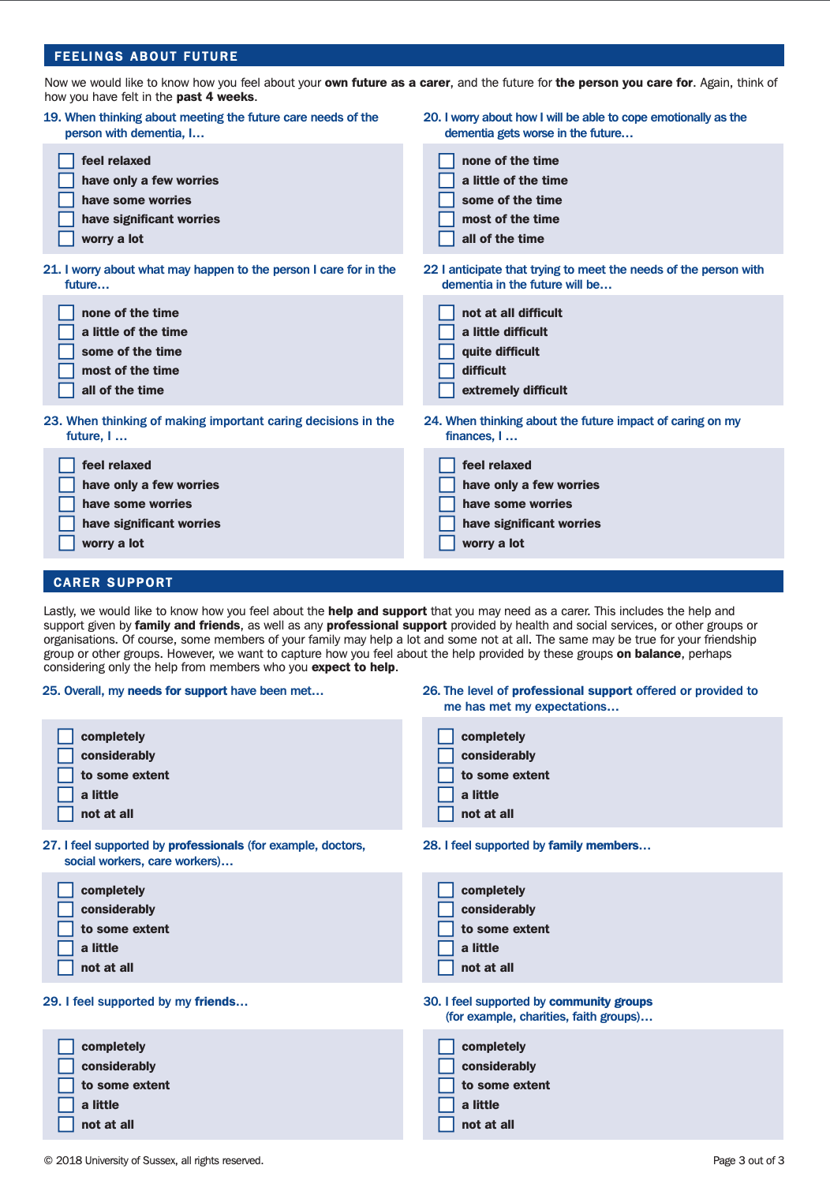
(Brown et al. (2019)

