Part 1 - RQ and hypotheses, as we practiced in Assignment #1 (part 1),

Research question:
Is there a relationship between the weight of the vehicle weight (“weight”) and miles per gallon (“MPG”)?

Null hypothesis
Among this population, there is no relationship between the vehicle weight (“weight”) and miles per gallon (“MPG”)?

Research hypothesis
Among the population, there is a relationship between the weight and MPG. We will assess the relationship between the years of school completed and the years of school completed by the mother

Part 2 - describing your variables (as we practiced in Assignment #2), no need for figures and skewness/kurtosis portion (part2),

Descriptive Analysis
Interval Variable
Weight and MPG are interval, quantitative variables. The intervals are a continuous measure of the variable, because each value is greater or less than another. . (Variables and Hypotheses. (n.d.). Interval variables a continuous measure of a variable in which each value is greater or less than previous. Ratio variables are characterized by the presence of an absolute zero on the scale. (Salkind & Frey, 2020, p. 31). The absolute zero option is an outcome where it is possible to have none of what is being measured. We will not have an absolute zero option in our scenario, because a car cannot weight zero.
The Pearson correlation for weight and MPG is used because they are continuous variables. (Blackboard, n.d.; Salkind & Frey, 2020). Pearson correlation reveals the strength between two linear variables. We will assume that they are proximity normally distributed. We assume a normal distribution and assume that there are no outliers in the data set provided. (Blackboard, n.d.; Salkind & Frey, 2020).
Linear means when you create a scatterplot graph, you draw a straight-line through all or some of the points. In a perfect correlation the line would go through all the points indicating the mathematical relationship between the variables. Perfect correlation also represents no randomness in the correlation. (Blackboard, n.d.; Salkind & Frey, 2020).
A Pearson correlation was conducted to assess a possible relationship between the weight of the vehicle (M = 3832.09, SD = 882.55) and MPG (M = 19.36, SD = 4.30).

Model Summary^{b}
Model | R | R Square | Adjusted R Square | Std. Error of the Estimate
1 | .884ª | .782 | .779 | 414.804
a. Predictors: (Constant), City MPG
b. Dependent Variable: Weight

Descriptive Statistics
 | N | Range | Minimum | Maximum | Mean | Std. Deviation | Variance
City MPG | 80 | 21 | 11 | 32 | 19.36 | 4.303 | 18.513
Weight | 80 | 3931 | 2469 | 6400 | 3832.09 | 882.549 | 778892.309
Valid N (listwise) | 80

Part 3 rationale for why a particular statistical analysis (regression) is used (part 3),

We will use a simple linear regression, because both weight and MPG variables and continuous, interval variables.

We are looking for a signification relationship between weight and MPG, where weight will predict a value for the MPG of the vehicle. The dependant variable is MPG and the independent variable is the weight of the vehicle (lbs.)
Linear regression is general method for estimating association between a continuous outcome variable and one continuous predictor variable. When we fit a straight-line through data. It is a prediction on one variable from another variable.
Least squares linear regression is a method for predicting the value of a dependent variable Y, based on the value of an independent variable X.

Part4 - and then the regression findings using the template provided in the instruction (part 4). No need to include the correlational results.

Variables Entered/Removedª
Model | Variables Entered | Variables Removed | Method
1 | Weight^{b} | . | Enter
a. Dependent Variable: City MPG
b. All requested variables entered.

Model Summary
Model | R | R Square | Adjusted R Square | Std. Error of the Estimate
1 | .884ª | .782 | .779 | 2.022
a. Predictors: (Constant), Weight

ANOVAª
Model |  | Sum of Squares | df | Mean Square | F | Sig.
1 | Regression | 1143.504 | 1 | 1143.504 | 279.617 | <.001^{b}
1 | Residual | 318.984 | 78 | 4.090
1 | Total | 1462.488 | 79
a. Dependent Variable: City MPG
b. Predictors: (Constant), Weight

Coefficientsª
Model |  | Unstandardized Coefficients |  | Standardized Coefficients | t | Sig.
 |  | B | Std. Error | Beta | t | Sig.
1 | (Constant) | 35.882 | 1.013 |  | 35.406 | <.001
1 | Weight | -.004 | .000 | -.884 | -16.722 | <.001
a. Dependent Variable: City MPG

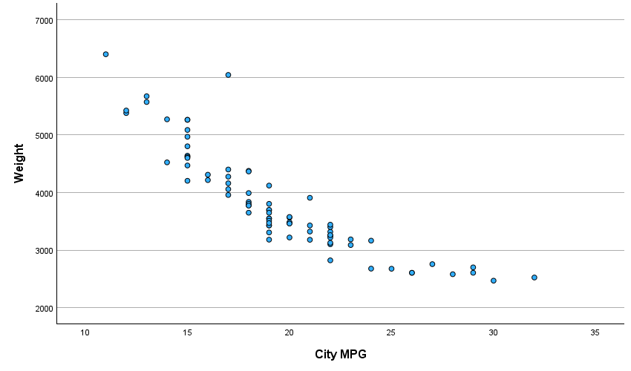

Reporting
A simple linear regression was calculated to predict MPG based on weight of the vehicle. A significant regression equation was found (F(1,78)=279.617,p<.001), with R2 of .782. Participants’ predicted weight is equal to _35.882+-.004 (MPG) weight when MPG is measured in lbs. Weight decreased -.004 for each gallon of MPG.
We have been asked to investigate the degree to which vehicle weight predicts miles per gallon.

References:
Salkind, N. J., & Frey, B. B. (2020). Statistics for people who (think they) hate statistics (7th ed.). Sage Publications, Inc.

Variables and Hypotheses. (n.d.). Variables and hypotheses [PDF]. Retrieved September 15, 2024. https://blackboard.cuchicago.edu/ultra/stream

Blackboard. (n.d.). Appendix A: Guides for selecting appropriate descriptive and inferential
statistics. Retrieved September 15, 2024. https://blackboard.cuchicago.edu/ultra/stream

