Concordia University Chicago
Doctoral Program

Assignment Title:
Date of Submission: | 9/8/2024
Assignment Due Date: | 9/8/2024
Course: | Quantitative Analysis – RES-7605-01
Section Number:
Semester/Term:
Course Instructor:
Certification of Authorship: I certify that I am the author of this paper and that any assistance I received in its preparation is fully acknowledged and disclosed in the paper. I also have cited any sources from which I used data, ideas, or words, either quoted directly or paraphrased. I certify that this paper was prepared by me specifically for the purpose of this assignment, as directed.

Student’s Signature: /s/

Ordinal Variable

The ordinal level of measurement is used when selected characteristic, such as levels of anxiety, but in an ordered way. This variable is considered an ordinal variable because it is at a level of measurement that places its values in a ranked order (Salkind & Frey, 2020). The purpose of the variable is to provide a measurement of the general level of happiness. (N = 565). . We have no idea how much higher on this scale an individual’s happiness is relative to another other person. We just know that “not too happy” is less than “very happy.”

This ordinal variable is categorical and includes possible responses organized into three categories. The ordinal variable selected for analysis from the survey is “my general level of happiness is: ___ Very happy, pretty happy, not too happy.” Very happy was given a value of 3. Pretty happy was given a value of 2. Not too happy was given a value of 1.

Statistics
General happiness
N | Valid | 565
N | Missing | 10

General happiness
 |  | Frequency | Percent | Valid Percent | Cumulative Percent
Valid | Very happy | 170 | 29.6 | 30.1 | 30.1
Valid | Pretty happy | 308 | 53.6 | 54.5 | 84.6
Valid | Not too happy | 87 | 15.1 | 15.4 | 100.0
Valid | Total | 565 | 98.3 | 100.0
Missing | DK | 1 | .2
Missing | NA | 9 | 1.6
Missing | Total | 10 | 1.7
Total |  | 575 | 100.0

Descriptive Statistics
 | N | Minimum | Maximum | Mean | Std. Deviation
General happiness | 565 | 1 | 3 | 1.85 | .659

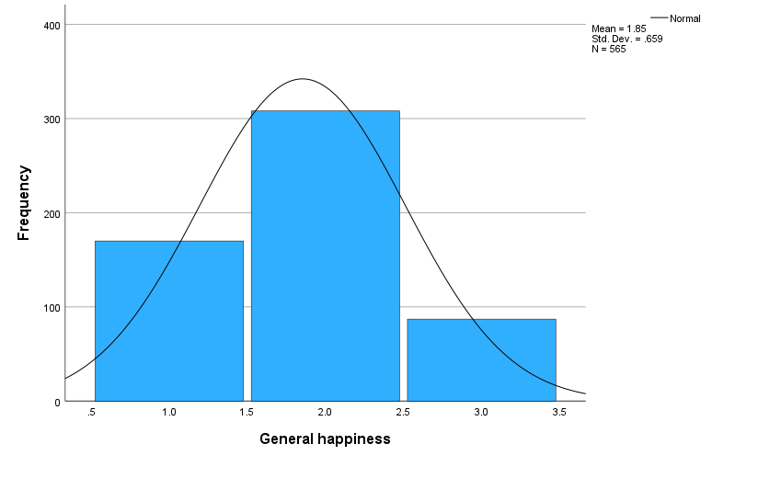
Analysis
For this data set, the mode is the category
“Pretty happy” which was selected by 308 (53.6%) out of 565 individuals that responded to this survey question. The mean of the population was 1.85, just below the value of 2 for pretty happy.

Nominal Variable
O Our nominal vaiable tested was gender. To fit into the nominal variable category a variable where “an outcome that fits into one and only one class or category” (Salkind & Frey, 2020, p. 30). be a nominal variable (female and male or prefer not to say). Nominal-level variables are “ names ” (nominal in Latin), and the nominal level is the least precise level of measurement. Nominal levels of measurement have categories that are mutually exclusive ;
The nominal variable chosen is Gender, with the variable name: “gender.” The purpose of this data was to determine the percentage of the sample (N = 575) that identified three different categorical gender options. Gender is a nominal variable, because it describes the variable's value outcome which can be placed in one and only one category.
The measure of central tendency for qualitative, categorical, or nominal data (such as gender) can be described using only the mode. It’ s not meaningful to talk about the mean gender. (Salkind & Frey, 2020, p. 30).
Statistics
 |  | Gender
N | Valid | 575
N | Missing | 0

Gender
 |  | Frequency | Percent | Valid Percent | Cumulative Percent
Valid | Male | 247 | 43.0 | 43.0 | 43.0
Valid | Female | 328 | 57.0 | 57.0 | 100.0
Valid | Total | 575 | 100.0 | 100.0

Descriptive Statistics
 | N | Range | Minimum | Maximum | Mean | Std. Deviation | Variance
Gender | 575 | 1 | 1 | 2 | 1.57 | .495 | .245
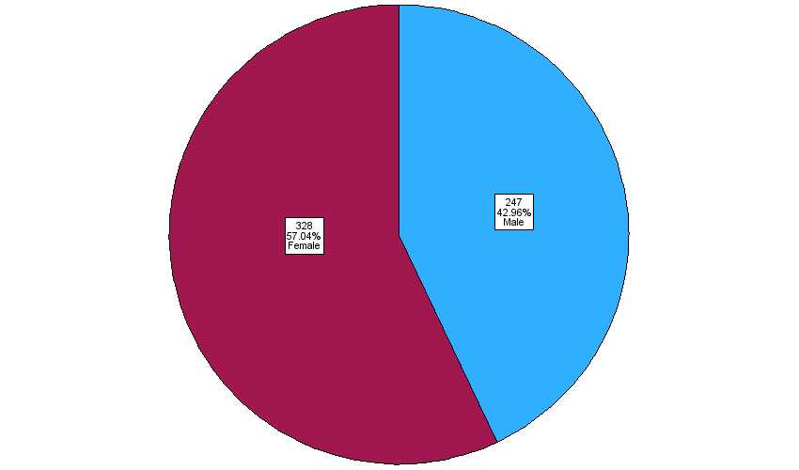

Analysis
For nominal variables, the frequency and mean are appropriate levels of measures in the categorical, nominal dataset (Fitzgerald & Fitzgerald, 2013). Here the mean is 57% female, 328 frequency and 43% male, 247 frequency.

Ratio Variable
Age is an interval, quantitative variable. The intervals are still a continuous measure of the variable even though they are grouped, because each value is greater or less than another. . (Variables and Hypotheses. (n.d.). Interval variables a continuous measure of a variable in which each value is greater or less than previous. Ratio variables are characterized by the presence of an absolute zero on the scale. (Salkind & Frey, 2020, p. 31). The absolute zero option is an outcome where it is possible to have none of what is being measured.
This variable also has an ordinal aspect, because the level of measure for age-specific results, are not available due to the loss of age specific-results. The interval gathering of data do not provide for individual age level of measurement; there is no specific indication of how high a value is in relation to another at a specific age. Variables and Hypotheses. (n.d.).
The ratio variable chosen is “What is your age”, with the variable name: “age.” This variable offers an outcome we where it is possible to have nothing of what is being measured, because one of the response choices is “prefer not to state”. This is missing data makes the comparison a bit harder, because it is not as if the responder does not have an age. If they are responding, then they are alive and have an age, so the comparison suffers slightly.
Statistics
 |  | Age of respondent
N | Valid | 573
N | Missing | 2

 |  | Frequency | Percent | Valid Percent
Valid | Under 31 | 119 | 21 | 21
Valid | 31-40 | 136 | 24 | 24
Valid | 41-50 | 125 | 22 | 22
Valid | 51-60 | 88 | 15 | 15
Valid | Over 60+ | 105 | 18 | 18
Valid | Total | 573 | 99.7 | 100.0
Missing | 99 | 2 | 0.3
Total |  | 575 | 100.0

Descriptive Statistics
 | N | Range | Minimum | Maximum | Mean | Std. Deviation | Variance
Age of respondent | 573 | 70 | 19 | 89 | 45.21 | 15.891 | 252.526

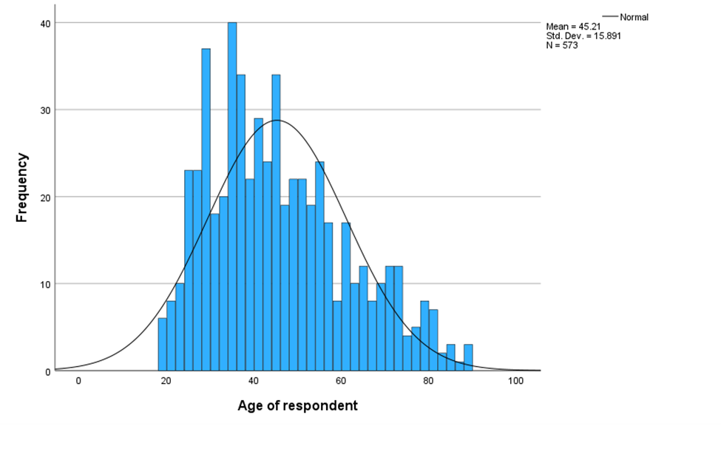
Analysis
For nominal variables, the frequency and mean are appropriate levels of measures in the categorical, nominal dataset (Fitzgerald & Fitzgerald, 2013). Here the mean age is 45, mode is the 31-40 age group with 136 instances. Minimum age is 19 and maximum age is 89.

References:
Salkind, N. J., & Frey, B. B. (2020). Statistics for people who (think they) hate statistics (7th ed.). Sage Publications, Inc.

Variables and Hypotheses. (n.d.). Variables and hypotheses [PDF]. Retrieved September 5, 2024. https://blackboard.cuchicago.edu/ultra/stream

